Safe Conversations™ Dialogue Workshop
Leader Guide
Version 09, February 2025
Facilitation Notes and Slide Directions
The following facilitation notes are offered to provide Safe Conversations™ Dialogue Workshop (SCDW) presenters with a fully-endorsed version of scripted content that may be used for the presentations they host. These notes and slide directions are not designed to dictate how certified SC LEADERs present and what they say, but to assist in promoting a standardized, consistent workshop delivery experience across the range of SC LEADER presenters. SC LEADERs are welcome to adjust the depth and complexity of the discussions and explanations based on the unique learning appetite and needs of each SCDW audience.
The content of this Leader Guide is shared under agreement only with properly-certified SC LEADER facilitators and may not be distributed without with permission from Quantum Connections Training, LLC. All rights are reserved.

Safe Conversations™ Dialogue Workshop

Slide 1
(no animation this slide.)
Welcome to today’s Safe Conversations™’ Dialogue Workshop! We are excited to share this interactive workshop with you and can’t wait to jump into conversations and exercises that get the activity started. So let’s go!


Slide 2
(no animation this slide.)
Let’s start with something you may have forgotten—or at least haven’t thought about in a while…


Slide 3
(You are WONDERFUL! appears on screen)
This statement – You are WONDERFUL--reflects that each of you are truly WONDERFUL—for all of your extraordinary uniqueness and for all of the things that make you amazing—and yet different from everyone else around you. There IS NO ONE ELSE LIKE YOU.
The phrase takes on even more meaning when you hear it from your own voice.
Repeat after me on the count of three, in your strongest, most confident voice say “I am WONDERFUL!”
(advance bullet: (I am wonderful!)
One-two-three- I am WONDERFUL!
Similarly, let’s join together on the count of three, in a strong, confident voice reminding all of us in today’s workshop: “We are WONDERFUL!”
(advance bullet: We are wonderful.)
One-two-three- We are WONDERFUL!
Because of that, it’s OK for the people around you to hold you in respect and to have a sense of wonder for the ways that make you so special. Similarly, you might even rekindle your own sense of wonder in the variety and uniqueness of the people around you.
Our hope is that this sense of wonder is rekindled in all of us. Connection takes on a whole new dynamic when we see the world with a sense of wonder about the people in it.

Slide 4
(no animation this slide.)
We’re going to begin by encouraging YOU to spend some time with why you’re here…

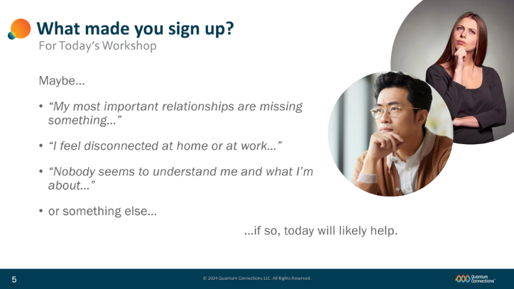
Slide 5
(first bullets “Maybe…” and “My most…” appear on the screen)
…and what might have motivated you sign up for today’s Safe Conversations’ Dialogue Workshop.
For some of you, perhaps there’s something missing in one or more of your most important relationships.
(advance bullet “I feel.”)
For others, maybe it’s a feeling of disconnection at home or at work.
(advance bullet “Nobody…”)
Still others might just feel that no one seems to understand who you are at heart or what you’re all about.
(advance bullet (“…or something else…”))
There might be a number of different reasons beyond those, as well.
(advance bullet “…if so,… “
In all of those cases, the good news is that the skills and behaviors we’ll discuss today will likely help.

Slide 6
(no animation this slide.)
Let’s make some introductions: first about the workshop and then, most importantly, we’ll get introduced to all of you.

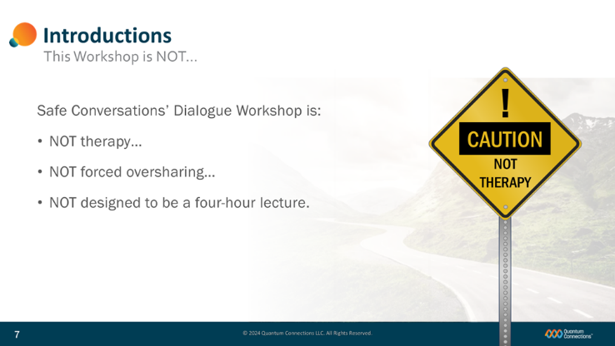
Slide 7
As we introduce the workshop today, it’s important to point out what the session is NOT:
(advance bullet (Safe Conversations’…), (NOT therapy,) and road sign)
Today’s session is NOT therapy.
Today’s discussion is going to talk about the many ways that we can become more aware of ourselves and about others. In the process, it’s entirely possible that thoughts about past events may privately come across your mind. If you find that there are personal issues you’d like to address at your own pace, there are phenomenal professional resources available to constructively work thorough those things. We’d encourage you to seek out those helpful resources when the time is right.
(advance bullet (NOT forced oversharing…))
This discussion is educational in nature and is not intended to force you to reveal sensitive issues you might not be ready to share publicly. We pledge to preserve a fully safe and secure environment—and in that space, you will each have the discretion to share however much or however little you’d like to share with those of us in the workshop. All of the details shared in today’s discussion are to remain within the boundaries of today’s discussion.
(advance bullet (Not designed…))
And, very important is that today’s discussion is NOT designed to be a 4-hour lecture, with someone talking AT YOU for hour after hour.
But that takes willingness and input from each of you to participate in our discussions and add your thoughts, ideas, and experiences to make the workshop come alive. With your help, I’m confident that we’ll be able to do just that!
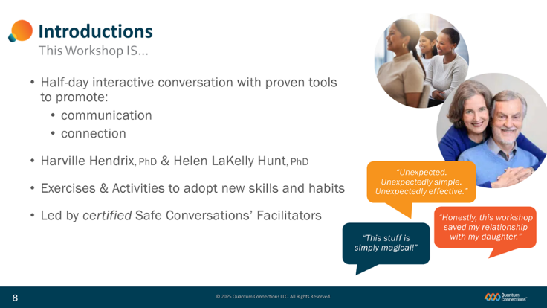
Slide 8
(first bullet “Half-day…” appears on screen)
Today’s workshop is a half-day conversation combining some innovative ideas with…
(advance bullets (communication), and (connection))
Powerful tools to promote more 2-way dialogues that grow your communication skills and your ability to build lasting connections.
(advance bullet (Harville…))
All of today’s content is built upon the foundation of four decades of clinical expertise and real-world experience by world-renown relationship experts and best-selling authors Dr. Harville Hendrix and Dr. Helen LaKelly Hunt. There’s a good chance you’ve seen and heard of their transformational work before today.
(advance bullet “Exercises &…”)
You’ll be pleased to know that we’ve mixed in lots of breakouts and practice exercises focused on getting you talking and practicing the skills and behaviors that will make a difference for you.
(advance bullet “Led by certified…”)
As for me (us), today’s Safe Conversations’ Dialogue Workshop is presented by (me and my partner), fully-certified Safe Conversations’ Facilitators.
(Insert SC Leader bio’s.)
It is not an overstatement to suggest that these new behaviors and skills will change your life once you make them a regular part of the way you interact with people. For decades, Safe Conversations Workshop participants have been sharing the same kinds of feedback with us, over and over:
(advance bubble (Unexpected…))
unexpectedly simple, and unexpectedly effective,
(advance bubble (Honestly…))
this workshop saved my most important relationships, and…
(advance bubble (This stuff...))
this stuff is simply magical.
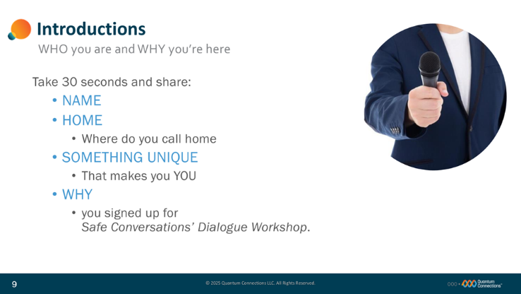
Slide 9
(no animation this page)
Let’s shift the discussion back to you and give you each a chance to tell us a little about yourselves.
As each of you introduce yourselves, I’d love for you to share WHERE you’re from, SOMETHING ABOUT YOU that makes you unique, and WHY you signed up for today’s Safe Conversations’ Dialogue Workshop.
Take 30 seconds or so to share your introduction, [(where appropriate) and when you finish, pick someone from the audience to go next.]
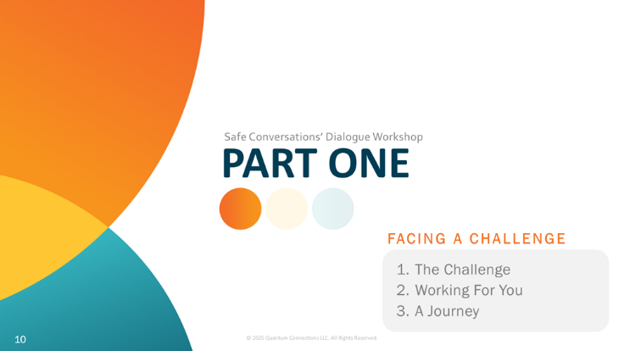
Slide 10
Today’s workshop is divided into three parts. After each part, we’ll be able to take a brief ‘stand and stretch’ bio break to help you stay alert and engaged.
(advance bullet (1. The Challenge…))
In our first section, we’ll address the challenge at hand, talk about a powerful force that’s actually working for you and finally position this as a “journey” you might seriously consider taking.

Slide 11
Let’s begin with a conversation about one of the most significant challenges involving people today—a challenge that affects the way people get along with one another and the way that they pursue relationships with each other.

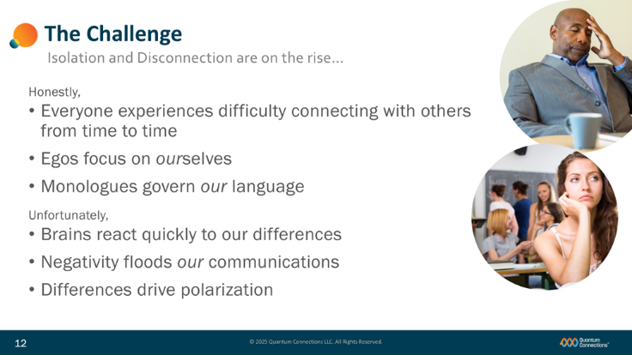
Slide 12
The challenge for people today—people like us--is that isolation, loneliness, and disconnection are on the rise all over the world. People can be hard to figure out, and sometimes relationships can be tough to navigate.
(advance bullets (first bullets (Honestly) and (Everyone…))
If we’re honest, we’ve all probably experienced days when we feel like it’s not easy to get along and make connections with other people, or to talk and stay connected with the people we know.
Unfortunately, several factors can work against us and make those conversations and connections hard for us to maintain these days.
(advance bullet (Unfortunately,) and (Brains…))
For instance, our brains have actually evolved over tens of thousands of years to focus on our differences—making them one of the first things we notice about other people.
(advance bullet (Egos…))
Our ego’s have been conditioned to place ourselves at the center of our worlds, making our own image, status, welfare, and reputation some of our highest priorities.
(advance bullet (Monologues…))
The way we have learned to talk to one another is actually talking AT one another- using a sequence of one-way messages called monologues that stress our ideas, our agenda, and our timeframes to other people.
(advance bullet (Negativity…))
In a constant battle to catch our attention, negativity predominates the tone of more and more forms of communications, featuring some routine degree of blame, shame, or criticism.
(advance bullet (Polarization…))
And today, more than ever, a kind of polarization has taken hold of many of our opinions and belief systems. We seem to regard many of today’s issues as either a right way and a wrong way, or my way and the wrong way. There just doesn’t seem to be much moderation, concession, or compromise in many of our conversations. In response, this intense polarization seems to drive us to turn up our volume—when we should be turning up our tolerance for difference and thirst for understanding, instead.
All of these things tend to make harmony between two people tougher and tougher to experience.
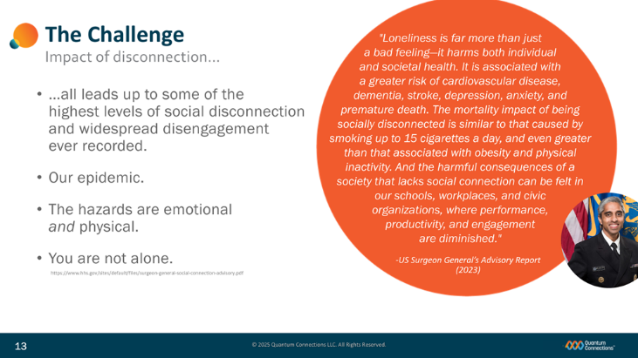
Slide 13
(first bullet (…all leads…) appears with slide)
…And all of those factors (on the last slide) now lead us to some of the highest levels of social disconnection and disengagement on record.
(advance bullet (Our epidemic…) and (The hazards…))
The US Surgeon General’s 2023 Advisory Report on Loneliness and Isolation declared that social disconnection in the United States has now reached epidemic proportions. Beyond our borders, the world is witnessing record-levels of social disconnection and the physical impacts on our society are as severe as the emotional impacts.
(advance graphic dot and photo)
The Surgeon General goes on to report that the harm caused to our health by this disconnection is considered similar to that caused by physical inactivity and obesity—and according to the US Surgeon General, is equivalent to smoking up to 15 cigarettes a day!
(advance bullet (“You are…”))
While there are many serious challenges to staying connected today, just remember that—if you feel that way--you’re not alone. We can all learn how to better communicate, and better connect, and beginning with this workshop, slowly we’ll begin to reverse this alarming trend.

Slide 14
(no animation this slide)
Some good news in your work against the challenge of miscommunication, isolation and disconnection, is that you’ve got a pretty powerful force working for you.

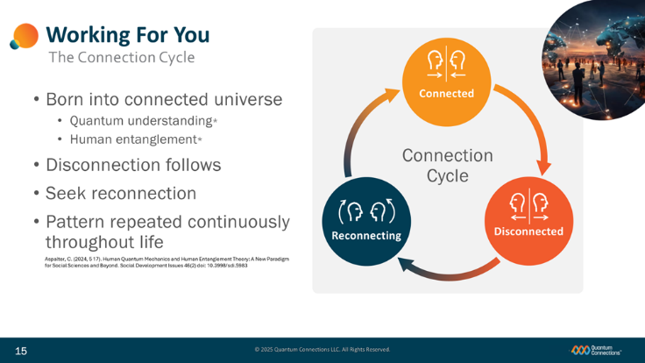
Slide 15
Specifically, we’re talking about our growing understanding of the Connection Cycle and our Quantum universe.
(advance (Born into…), (Quantum understanding…), “Connected” and circular image graphics)
Let’s go back in time, all the way back to the day you were born. We now know that we were all born into what’s known as a connected universe- a universe far more interconnected than most people first believed. In the last 100 years, quantum field theories gave rise to quantum social sciences—forms of science that helped round out our collective knowledge about how the world, how particles in the world, and how people in the world interact. Everything touches everything; everyone touches everyone. It is inescapable and we’re only finally beginning to understand it.
(advance bullet (Human entanglement))
We now firmly believe that people are NOT purely independent actors, operating in isolation in their own separate worlds, but instead that people –our actions and our energies--are entangled and actively influence each other every time we are near each other.
Early in life in this entangled reality, we all experience an ideal state of connection- where air, food, physical contact, and emotional connection are all provided for us by parents and caregivers. All is initially right In our worlds.
(advance bullet (Disconnection…), arrow and “Disconnected” graphic)
But at some point, that early state of ideal connection is lost, and we all experience the shock, pain, and trauma of disconnection. For many of us, those early disconnections imprint on our brains programming we spend the rest of our adult lives trying to re-satisfy—with the way we spend our time and resources and the people we pursue relationships with as adults.
(advance bullet (Seek reconnection…), arrow and “Reconnecting” graphic)
As soon as disconnection happens, we automatically begin work to reconnect, respecting an innate or fundamental desire to recover connection.
(advance bullet (Pattern…), last arrow and “Continuous Cycle” graphic)
This pattern of enjoying connection, experiencing disconnection, and seeking reconnection repeats itself constantly for virtually all of us—and it happens continuously throughout our entire lives.
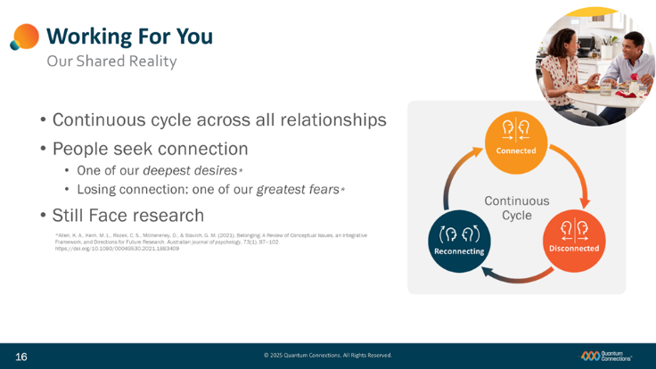
Slide 16
(advance bullet (Continuous cycle…) and (People seek…) and Connection Cycle graphic)
Our shared reality is that this Connection Cycle is happening right now in real time for all of us, across all of the relationships we pursue.
(advance bullets (One of…) and (Losing…)
You might ask how powerful are the feelings that drive us to stay connected with other people and work to recover connection each time it is lost?
Research confirms that our need for connection and belonging competes as one of the strongest desires we have—both to avoid losing our relationships and to work to recover the ones we’ve lost.
(advance bullet (Still Face…))
One of the best demonstrations of the Connection Cycle is presented by Dr. Edward Tronick in his landmark “Still Face” research from begun back in 1975…
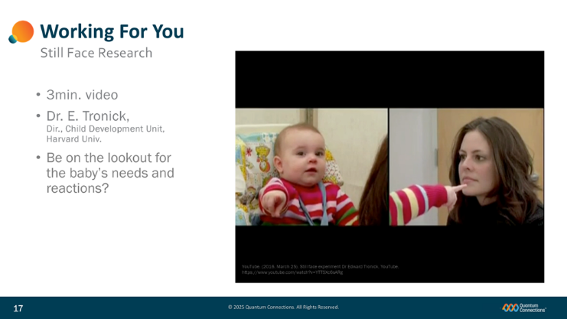
Slide 17
Watch this short 3min video and look for the fundamental joy of connection, for the pain of disconnection, and for the immediate desire to re-connect—all in a matter of moments for this small child.
(Click play button to play video in Fullscreen)
(optional additional facilitator comments)
- What did you notice about the baby’s reactions and the need for attention?
- Did you notice that the mother wasn’t mean to the baby, there was no yelling or negative talk? There was nothing overtly negative; however, the baby was still distressed because there was no feedback at all – positive or negative. There was no engagement or connection…just nothing. Even without negativity, the baby was still distressed due to the lack of connection.
- In summary, humans need to feel affirmed. We need people to acknowledge our existence and give us positive feedback – to connect with us and create psychological safety.
- We seek engagement. We seek to know that we are being heard. We want our existence as a human to be acknowledged
- When our engagement is not acknowledged, we feel distress and disconnection.
- Our brains interpret disconnection as danger, since connection was necessary for survival in the early, primitive days of humanity. Early on, being disconnected from the tribe of humans meant you were on your own to hunt for food, protect yourself from predators and gather resources.
- Today, when we feel disconnected from others, we act out in various ways as you saw with the baby in this video.
- This fundamental need starts in infancy and never goes away since it is a basic part of being human.

Slide 18
(no animation this slide)
We’re going to move ahead and discuss a journey that might be worth taking…

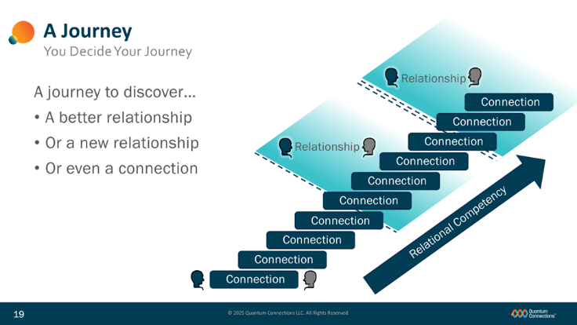
Slide 19
(first two bullets appear with slide)
You’re here is a Dialogue Workshop, but we not here just to add dialogue into your lives. If that’s all we did, you might talk more, but might not get anywhere meaningful with it.
This ‘journey’ is a personal development journey over time and it will hopefully deliver some really meaningful results: for example, help you discover a better version of an existing relationship, or a group of relationships that are near and dear to you.
(advance bullet (Or, a new…)
For some of you, this journey will help you create a brand new relationship that didn’t exist before, and
(advance bullet (Or, even a…)
For others, you might simply be trying to start things off just by building a new personal connection where only an acquaintance stood before.
(advance first connection graphic)
In any case, at whatever level works for you, these new skills will help you build connections with the people around you,…
(advance other Connections graphics)
… and then build successive connections with that person, stacking them one after another, as you grow closer and better connected to the people in your life.
(advance first “Relationship” graphic)
For some of you, after establishing a series of connections, you’ll eventually recognize that you’ve crossed over into “relationship” territory.
(advance next two “Relationship” graphics)
For others, it might take longer, or a greater number of connections before you begin to feel the bonds of what you’d consider a relationship.
(advance “Relational Competency” graphic)
In each case, these new skills from today’s workshop will be the tools you’ll use on this journey to help you develop connections and relationships and the relational competency to sustain them over time.
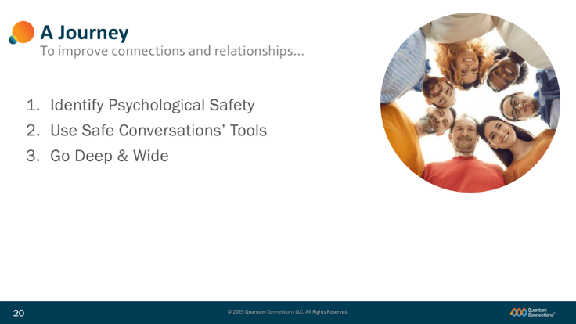
Slide 20
(advance bullet (1. Identify…))
As we suggested earlier, simply adding dialogue to your connections and relationships might not change much and may not help anyone overcome differences better-- unless a powerful force called psychological safety is present—so we’ll make sure that we first know how to identify psychological safety.
(advance bullet (2. Use…))
We’re also going to teach and practice the use of four (4) behavioral tools that will help us next create that psychological safety in order to turn talking AT people into Safe Conversations WITH people.
(advance bullet (3. Go…))
And finally, we’ll focus on building your confidence with these new tools by practicing them in a range of scenarios that highlight the depth and wide range of scenarios that they can help with.
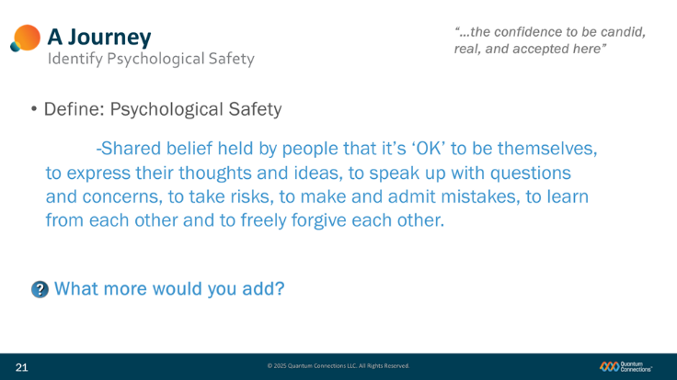
Slide 21
(advance bullet (Define…))
Let’s start by talking about psychological safety—what is it and how would you define it.
Does anybody have a good working definition that you use?
(advance bullet (Psychological…))
Havard Business Review (HBR) defined it this way:
…a shared belief amongst a group of people that feel:
- that it’s ‘OK’ to be themselves,
- to express their thoughts and ideas,
- to speak up with questions and concerns,
- to take risks,
- to make and admit mistakes,
- to learn from each other…
- and to freely forgive each other.
(advance bullet (“…the confidence…”))
Another way to define ‘psychological safety’ might be with this quote: “…the confidence to be candid, real, and accepted here”
(advance bullet (What more…))
What else would you add to the definition? Do you have any personal experience where you actually got to feel some of this psychological safety?

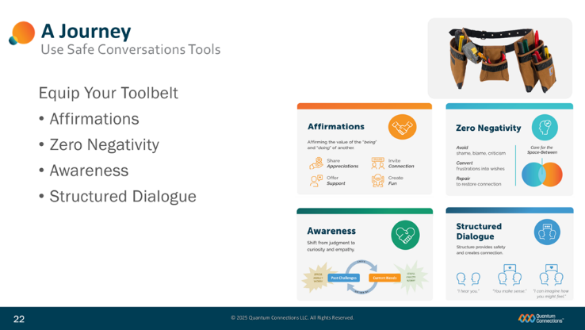
Slide 22
(advance bullet (Equip…) and toolbelt graphic)
Like any good handyman or woman, having the right tools on hand and at the ready can make all the difference in the world.
(advance bullets and Tools graphic)
We’re going to load up your “toolbelts” with four (4) effective tools that help you build psychological safety within the relationships that you care most about. Those tools include the sharing of affirmations, zero negativity, the use of an awareness model, and the Structured Dialogue.
These tools that we will teach and practice today will be your go-anywhere resources to hang onto and break out whenever you feel the need to support the psychological safety within the Spaces-Between that you’re a part of.
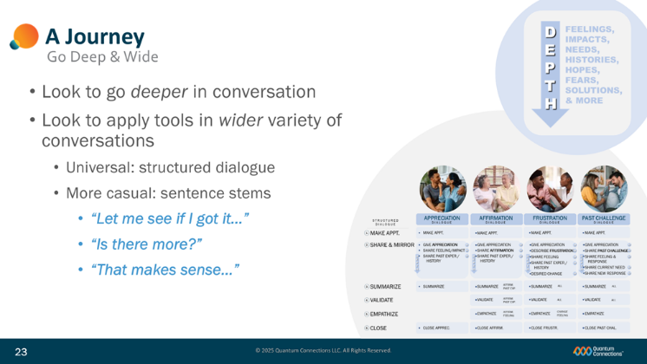
Slide 23
(advance bullet (Look to go…) and graphic))
As you become more comfortable in your Safe Conversations skills, you’ll find yourself routinely going deeper into the issues at the heart of your conversations and relationships. Sharing your thoughts and ideas between people will more regularly connect your feelings and emotions to the important needs, histories, hopes, and fears that all play a role—and do it a lot more often.
(advance bullet (Look to apply…)
Using these new tools will also help you in a wide range of very different conversations and situations. The same universal dialogue steps and skills can help create psychological safety and connection in some of the happiest, most pleasant discussions, as well as in some of the most sensitive and difficult ones. Learn just one set of tools and you’re covered.
(advance bullet (Universal))
When it comes to how you’ll use dialogue in the Space-Between, you’ll have a couple of options:
We’ll start out teaching a simple, structured dialogue process with six easy steps that works in virtually any situation.
(advance bullet (More casual…))
For some of the most casual occasions, a second option is to use parts of that structured dialogue--or what we call sentence stems-- anywhere they can help out the conversation with more connective words and phrases.
Both the depth and the width of the application of your new Safe Conversations’ Skills are what make them so useful to you on your developmental journey.

Slide 24
Now, we’d like to jump in and try out one of the most important skills you’ll add today.

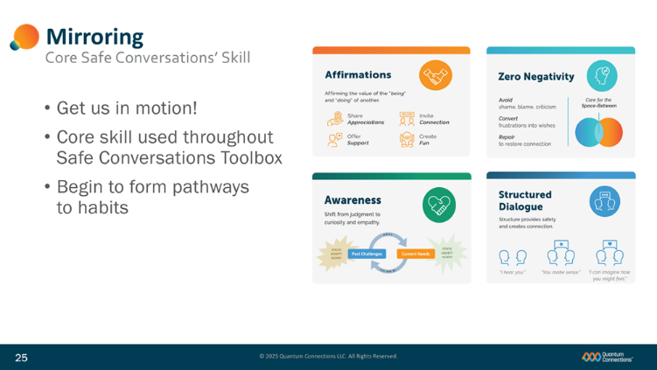
Slide 25
(no animation this slide)
The skill is called Mirroring and it shows up throughout the Safe Conversations Toolbox.
This practice will give us a chance to get talking and get moving!
We’ll describe Mirroring for you as a skill and then we’ll step back and give you each a turn to give it a try.
As you’ll see today, the single best way to begin creating new habits that improve connectivity is to actually practice them yourselves—in a perfectly safe, fail-proof environment like this one.
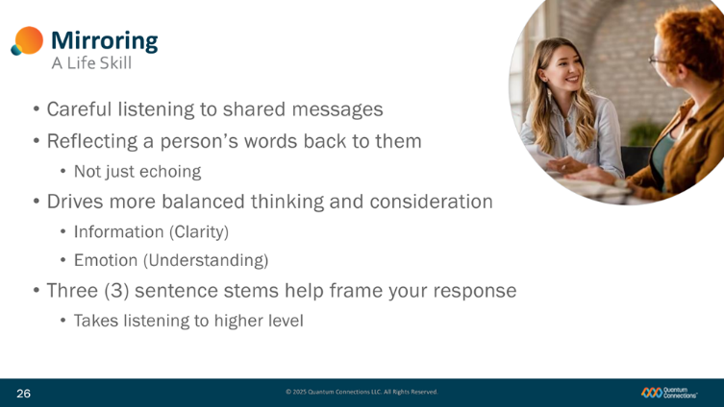
Slide 26
Mirroring typically takes place by the listener (or receiver) after someone else has shared some kind of thought, feeling, or idea.
(advance bullets (Careful…), (Reflecting…), and (Not…))
Once a message has been shared by the person we refer to as the sender, the person listening to and receiving the message mirrors or reflects back to the sender what they heard.
(advance bullets (Drives…), (Information…), and (Emotion…))
Depending on what was shared, the receiver mirrors back the information and details they heard to help improve clarity, or they mirror back the sentiments and feelings that they heard to help improve their understanding of the message.
(advance bullets (Three…) and (Takes…))
In either case, the receiver will be using special sentence stems to lead off the words and language they’ll mirror the sender with.
These sentence stems will actually promote a higher quality of listening and will support the conversation with more deliberate thinking, reasoning, and consideration.
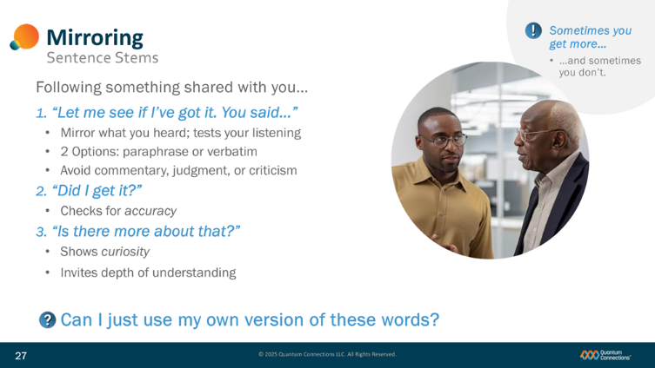
Slide 27
The three (3) sentence stems you’ll use to mirror someone are:
(advance bullets (Let me…), (Did I…), and (Is there…))
“Let me see if I got it.”
“Did I get it?”
“Is there more about that?”
It looks and sounds fairly simple, but the effect these sentence stems have is really amazing when used by a trained listener.
(advance bullets (Mirrors…+2))
The first one: “Let me see if I’ve got it…”
After someone shares something with you, wait for them to finish speaking and then say: “Let me see if I’ve got it. You said…”
You then mirror them back what you heard by either paraphrasing or repeating word-for word. Try not to change the language or meaning too much. Don’t try to filter, improve, or criticize the sender’s words. Your total focus is on the person talking and receiving the information as completely as possible. Listening to their message without judgment, negation, or a rebuttal will help the speaker feel safer right away.
(advance bullet (Checks…))
After you Mirror the speaker’s opening thoughts and message, you want to check for accuracy by asking:
“Did I get it?”
This step invites clarity with a commitment to capture the sender’s intended message accurately.
(advance bullet (Show… +1))
After confirming the accuracy of what you’ve mirrored back, you want to demonstrate genuine curiosity by asking:
“Is there more about that?”
This gives the Sender a clear invitation to go deeper and an opportunity to elaborate with more details, helping them feel fully acknowledged and heard.
(advance bullet (Can I…))
You might ask ‘Can I just use my own version of those three phrases?’ It’s a fair question. But we’d caution you not to stray, because other versions sometimes accidentally stumble into feelings that derail the dialogue. For example, instead of saying “Let me see if I’ve got it,” saying “Oh, so what you’re trying to say is…” That conjures up a failure to actually communicate, which is inherently negative.
(advance bullet (Sometimes you…))
One last thing: be prepared for a variety of responses when you do mirror another person. Sometimes, you’ll be surprised at the depth and detail others offer you—and other times, people will quickly end the mirroring process with “Nope, you got it.”
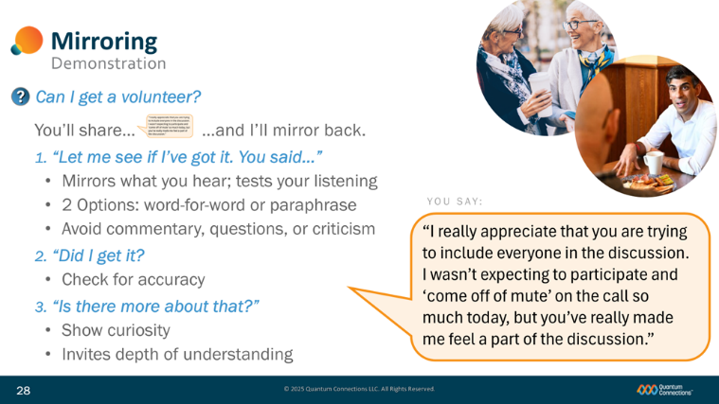
Slide 28
Let’s demonstrate the mirroring skill in action,
(advance bullet (Can I…))
and to do that, I’ll need a volunteer. Anyone?
(advance bullet (You’ll share…))
You’ll read and share something that I’ll provide on the screen, and I’ll do my best to demonstrate what mirroring looks and sounds like back to you.
We’ll leave the sentence stems on the screen so that everyone can follow along.
(advance bullet (Let me… +2))
For my volunteer, feel free to role play with me, and go as far, and as deep into the scenario as you’d like to go in the exercise.
Any questions? Here is our volunteer’s part…
(advance bullet (You say:) and large bubble)
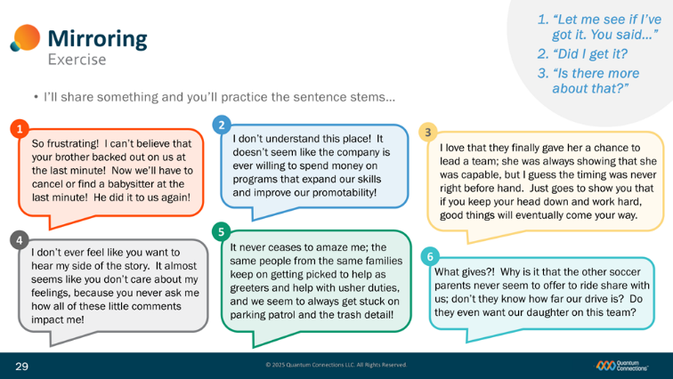
Slide 29
Now, we’ll take a lap around the room and I’ll give you a chance to practice the mirroring skills with some on-screen examples. I’ll read some messages one at a time and will call on a couple of you to help mirror back my thoughts.
I’ll also leave the Mirroring sentence stems up on the slide…
(advance bullets (Let me…) +2)
…to help you get comfortable with the new skill.
Any questions?
So who can I call on first…? : )
I’ll read these one at a time, and you will Mirror me back…
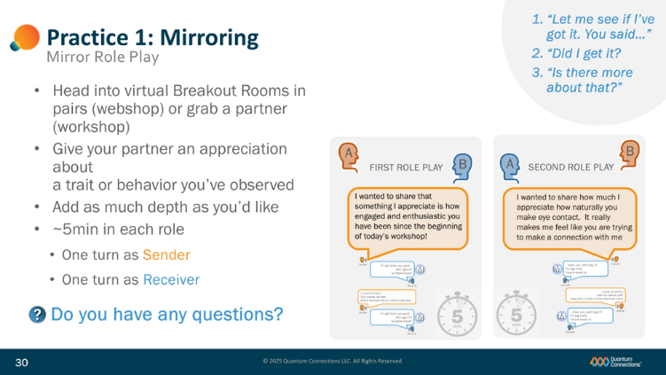
Slide 30
(advance bullets (Head into…), (Give…), and (Add…))
We’re now going to move into breakout rooms (or have you work with a partner in a workshop) to give you a chance to try out and practice your own mirroring skills.
When it’s your turn to share, share an appreciation about the other person: perhaps a trait or behavior that you’ve actually observed, or something you make up. In your role play, add as much depth as you’d like.
(advance bullets (5-8…), (One…), and (One…) and depth graphic))
You’ll each get a chance to mirror, taking a turn with each role, once as the Sender and once as the Receiver. Take 5-8 minutes for each role and have a little fun with it. : )
Jot down on a notepad the stems if you think you’ll need to have them in hand.
(advance bullet)
Any questions for me? OK, let’s take (xx) minutes and then we’ll get back together and discuss.

Slide 31
(Discuss the practice experiences of program participants.)


Slide 32
(No notes or animation this slide)

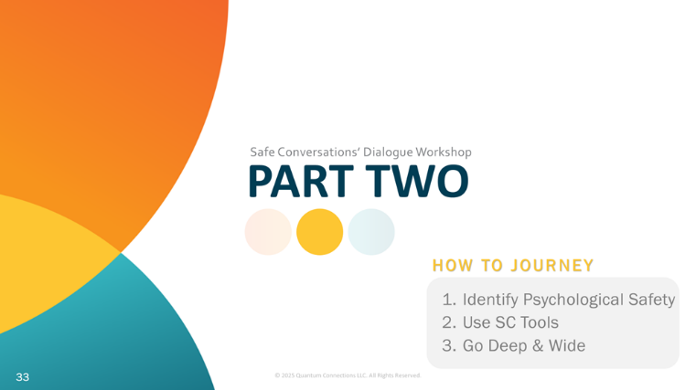
Slide 33
(no animation this slide)
Now we’re on to the second part of today’s Safe Conversations’ Dialogue Workshop. If Part One closed out with Exactly WHAT things to do to boost connectivity in your relationships, like creating psychological safety with Safe Conversations Tools, then Part Two will now explain exactly HOW to do that. The three things will discuss are identifying what psychological safety looks like, how to use the four (4) SC Tools, and going Deep and Wide with the use of those tools.
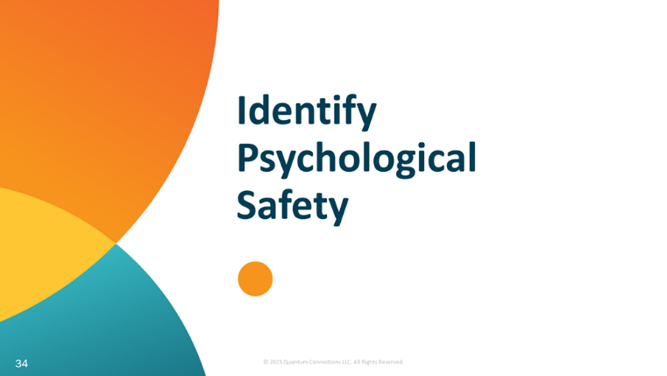
Slide 34
(no animation this slide)
We’ll start with further identifying psychological safety.

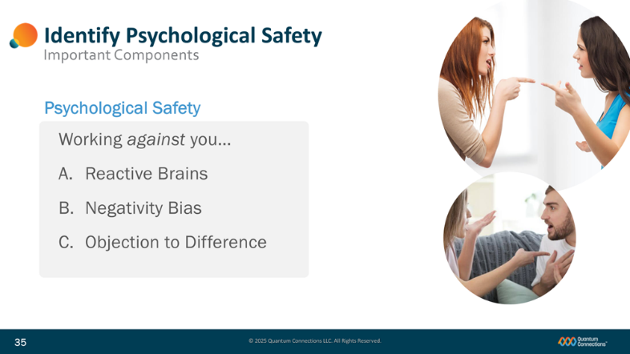
Slide 35
Being able to identify psychological safety—like knowing when you have it and when you don’t—also means moving past the definition and learning about the things that make it tough for people like us to create.
(advance bullet (Working against you…) and list)
To do that, we’re going to talk about a few things that work against you creating psychological safety:
- Our reactive brains,
- Our negativity bias, and
- Our objection to difference.
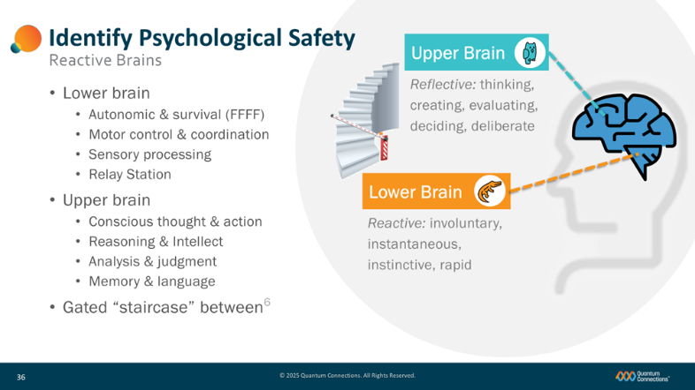
Slide 36
Much of what we’ll discuss involves the structure of the brain and some basic brain functions.
(advance brain graphic, (“Upper Brain” and “Lower Brain”))
It’s widely known that the human brain is one of the most complex organs on the planet, so for our purposes today, we’ll simplify its function into two basic components—the Upper Brain and the Lower Brain.
(advance bullet (“Lower brain” and “Reactive…”))
The Lower Brain is made up of three parts: mid brain, hind brain and brain stem, and it oversees automatic body functions for survival—things like breathing, circulation, and digestion—as well as our Fight, Flight, Freeze, and Fawn (FFFF) reflex. The Lower Brain is also built to quickly react and relay the signals coming into the brain around to the other parts of the brain where they’re fully processed.
(advance bullet (“Upper brain” and “Reflective…”))
The Upper Brain –principally the four lobes of the cerebral cortex--is charged with more deliberate reflection: conscious thought, reasoning, and analysis. The use of the Upper Brain helps our thinking become more balanced and complete, but doesn’t generally get involved unless first cleared into action by the Lower Brain.
(advance bullet (“Gated staircase…”))
Mechanisms in the Lower Brain work like a gated “staircase” and only allow thoughts to proceed up into the upper brain if certain conditions are met.
For example, in the external world around your body, the Lower Brain first checks to make sure there are NO physical threats to our bodies—things like danger, harm, and violence-- before moving thoughts up to the Upper Brain.
Similarly, in the internal world within your head, the lower brain similarly checks to make sure that there are NO psychological threats to our egos and identities—things like panic, fear, stress, or anxiety– before allowing the Upper Brain to get involved.
In both cases, if threats are sensed, the body’s Fight or Flight reflex in the Lower Brain takes charge and quickly directs a response. Whether that’s getting the body or mind out of harm’s way, or going on the attack against threats, a person’s immediate defensive response often lacks the benefit of Upper Brain thinking—is often judged later as hasty, rash, or even unwise.
That’s why establishing safety and security is so important around the people you’re communicating with. Our brains are built to look for it, and if they don’t see safety and security, our responses are rushed and our thinking is incomplete.
(NOTE: Another compelling theory on functional neuroscience was advanced by Nobel-laureate Daniel Kahneman when he described System1 /System 2 thinking in his best-selling work Thinking Fast and Slow (2011). Although not identical, the two explanations (Upper/Lower Brain and System1/2) are both similar enough to support the basic argument of reactive and reflective functioning from the human brain.)

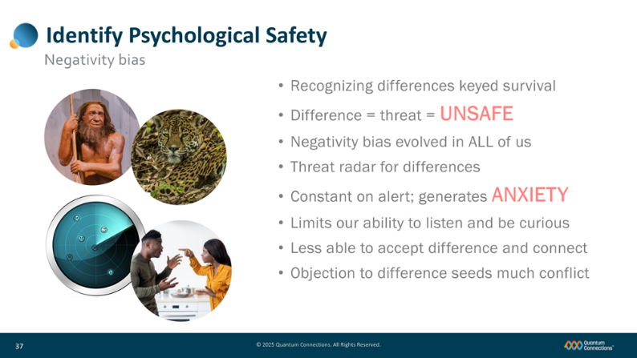
Slide 37
That our lower brains react quickly and instinctively is one thing. How we react quickly and instinctively is something else beyond that.
(advance bullet (“Recognizing…”) and caveman and jaguar graphics)
After tens of thousands of years, our brains have evolved to spot differences in our environment quickly and fear anything that challenges what we expect to see and hear. Our earliest ancestors that were able to recognize the unusual sound rustling in the grass, or able to spot the predator stalking in the shadows in time were the people that survived to see another day.
(advance bullet (“Differences… and “Negativity…”))
That evolutionary history has left us with brains that continuously scan for differences and point out anything negative or at odds with our expectations, because historically it’s the negative things that proved to be the most dangerous. This negativity bias is now a built-in behavior that occurs in all of us, hard-wired in the way our brains process the world today.
(advance bullet (“Threat…”) and radar graphic)
That ‘always-on’ search for negativity and danger operates a little like a threat radar. The “radar” has good intentions and works to protect us, keeping our bodies, egos, and self-esteem safe. But that threat radar also has the effect of keeping us always on alert, constantly suspicious, critical, and ready to object to differences in the outside world.
(advance bullets (“Constant…”, “Limits…”, and “Less…”))
This negativity bias creates anxiety for us by always being on the lookout for the next chance to react and protect us by objecting to the differences in something or someone. This anxiety often gets in our “emotional way” and limits our ability to fully listen, be curious, and make connections with people who have differences with us.
(advance bullet (“Objection…”) and conflict image)
By objecting to differences, we seek to protect and preserve our own identities. But in the process, we also create a lot of conflict in the world each time we find differences in it.

Slide 38
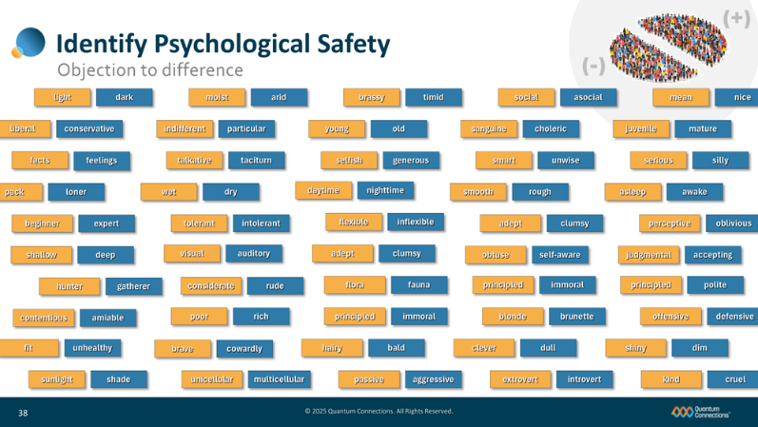
(first graphic (“considerate, rude”) appears with slide)
So now we understand that humans are always on the lookout to spot and recognize differences—differences like one person being more considerate and one person less so, for example. That we recognize difference and then make a judgment about it is just something that we come by naturally.
(advance next four differences)
And it would be ok, it differences between people came along every now and again.
Some MEAN, some NICE;
Some CLEVER, some DULL;
A little YOUNG, OLD here;
A little BEGINNER, EXPERT there.
(advance remaining bullets (five columns))
But our reality is that we are flooded with a ton of differences every day, in all kinds of different ways.
Variation and variety are everywhere in the natural world and help spread differences into every pocket of the human population. All of those differences do the world a lot of good and are an integral part of the life cycles in nature—and make must-have things like resiliency, stability, and diversity possible.
But have you also noticed, though, that the very existence of difference is often enough to turn two people away from each other, to discourage conversation, and to prevent a real connection from ever happening? Feeling that our egos, identities and self-images are being threatened, we object to the differences we identify. Instead of drawing us together, we find that the differences in each other sadly disappoint and divide us instead.
(advance title bullet (“Polarizing…”) and polarize graphic)
Now in a group of people, rather than using differences to drive us to learn new things that are unlike or unfamiliar to us, we allow differences to drive us towards people with similar habits, traits, and behaviors just like our own. On a larger scale, this alignment serves to polarize our population and divide us into ‘like groups’ that think like us, dress like us, shop like us, vote like us—and if you look around in today’s world, it’s happening at a faster and faster pace.
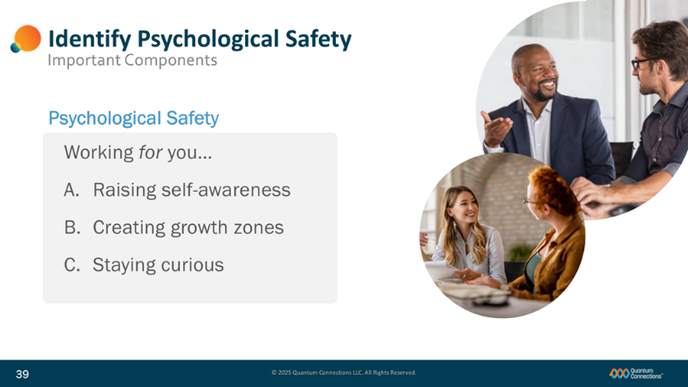
Slide 39
(No animation this slide)
While some things work against you, there are things you can do that help you create psychological safety, things that work for you like
- Raising self-awareness,
- Creating growth zones, and
- Staying curious.

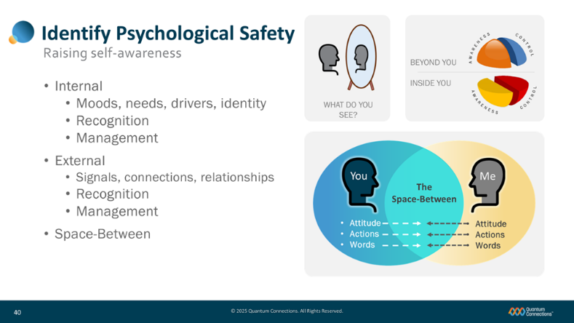
Slide 40
One of the most important behaviors that will help you raise psychological safety is to routinely measure your own level of self-awareness.
(advance mirror graphic)
When you look in the mirror, how much do you really understand about your own identity, your moods and your needs? All of the huge amounts of good inside of you, and even some of the less-than-great that we all have? How much do you pay attention to how well you read, react, and interact with other people around you?
(advance bullet beach ball graphic)
Self-aware people are said to understand both their internal and external interactions.
(advance bullet (“Internal”) and list)
Internally, self-awareness is about recognizing and managing your moods, needs, and who you really are inside. For example: if you’re having an ‘off-day,’ do you know why?
(advance bullet (“External”) and list)
Externally, self-awareness is about recognizing the signals and clues involving the people, relationships and social situations beyond you and again, managing them in a productive way. For example, when you walk in an office or space, can you quickly and accurately ‘read the room?’
(advance bullet (“Space-Between”) and Space-Between graphic)
An important concept that combines both internal and external self-awareness is a very special place called the Space-Between. The Space-Between is the physical space between two people in position to connect with each other—and it’s here where those two people put that self-awareness to work. That same space is filled with the attitudes, actions, words—and especially the energies—that both people put into the space. The Space-Between can be positive and it can be negative—and can go a long way towards drawing people IN towards connecting with each other, or driving them OUT away from each other.
Paying more attention to your own level of self-awareness and to the energies you’re putting into the Space-Between will help you better tune yourself and better communicate with the people that matter most to you.
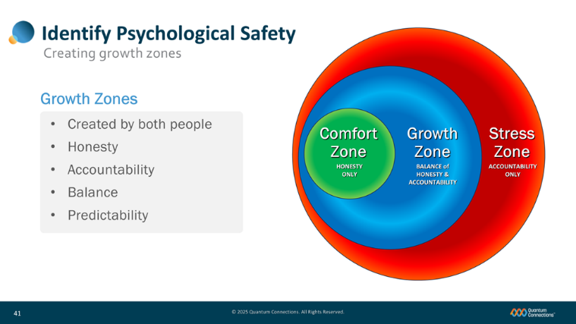
Slide 41
Another behavior that will help promote the creation of the right kind of psychological safety is to continually create growth zones in your personal spaces.
(advance bullet (“Created by…”))
Growth zones are special places between two people with the right balance of psychological safety and accountability.
(advance bullet (Honesty) and Comfort Zone graphic)
If all you focus on is the safety to be perfectly honest with other people, you might create a very comfortable space for yourself to express whatever’s on your mind. However, safe spaces are not intended to give anyone permission to say and do hurtful things to others under the cover of honesty. What might be a very comfortable space for you, could end up being very uncomfortable for someone else.
(advance bullet (Accountability) and Stress Zone graphic)
On the other hand, if all you choose to focus on is holding other people accountable for their words and feelings, you end up creating a very toxic space filled with blame and attribution called the Stress Zone.
(advance bullet (Balance) and Growth Zone graphic)
The answer to is add a balance of both psychological safety and accountability into the same space between two people. By doing that, people are free to express themselves honestly, but will do so in a way that promotes ownership of the things that are said and preserves responsible, constructive communication between both people.
(advance bullet (Predictability))
Effective psychological safety grows stronger and more useful between two people when the presence of these growth zones become steady and predictable.
Anticipating those safe and receptive behaviors and the balanced mix of both honesty and accountability, people grow accustomed to sharing their real feelings, but in a way that respects how their words and feelings will impact the other person.
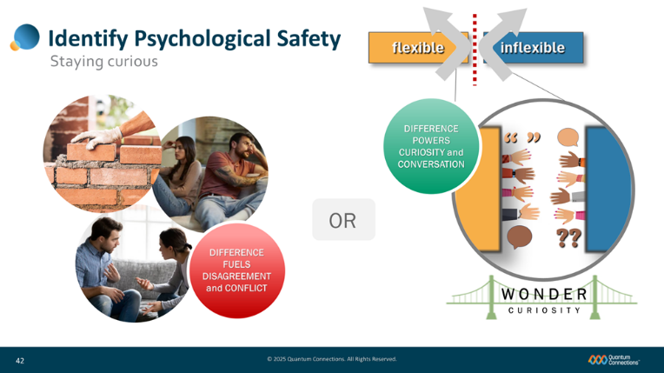
Slide 42
(advance flexible-inflexible box graphic)
We spoke earlier about the way most people react to differences in other people—in this case one person who happens to be more flexible and accommodating and another who’s less so. Most times we instantly read those differences—and then obey the objection to difference coming from the lower brain.
(advance redline and turn away arrows, first two graphic circles)
Quick to judge, we put up emotional walls between ourselves and others and turn away from the difference the other person presents.
(advance argument and red circle graphics)
If we’re energized or emotionally charged, those objections to differences can quickly turn right into tension and conflict.
I want to encourage you to try something a little different the next time this happens.
(advance (“OR”) and close-up circle graphic)
The next time you recognize a difference in someone else, I want you to gather up some fresh curiosity—and put it to work right where the difference occurs.
(advance hands and bridge graphics)
Knock down those internal walls, build a ‘wonder bridge’ and reach across the boundary with your curiosity, gestures, and questions to learn more about the difference and why it exists.
(advance green circle graphic)
Your goal is not to adopt someone else’s differences for yourself, or to convert other people over to your ways—but only to remain curious, become more aware and then accept that difference going forward—not as better, worse, but just something that makes us wonderfully –and powerfully ‘different.’
How you react to differences is a choice you’ll make dozens of times a day—to do the left, to wall up and feed conflict (in the red circle) or to do the right, to bridge across and learn (in the green circle) --and it is entirely up to you how you respond each time.
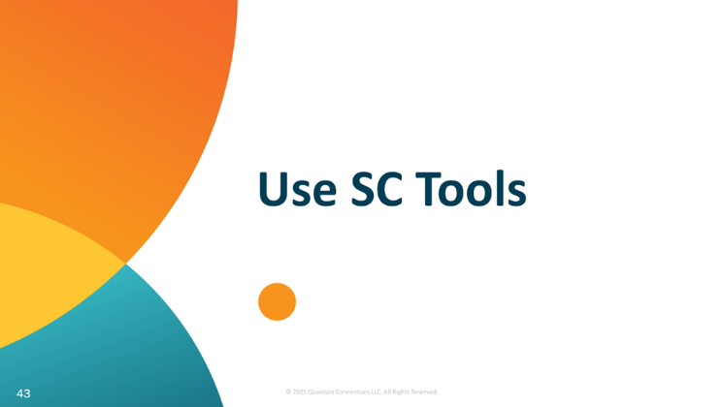
Slide 43
We’re now going to jump into your brand new toolbelt- and talk about how to use your four (4) new tools.

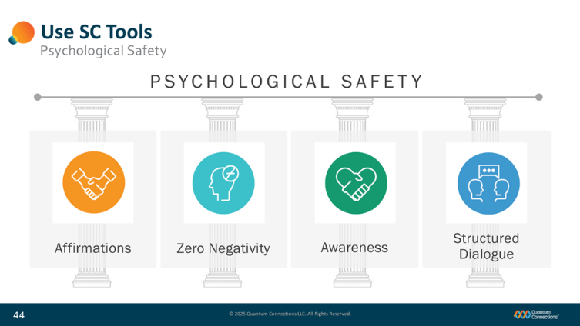
Slide 44
Within the Safe Conversations’ Dialogue Workshop, we’re now going to introduce and practice the use of four (4) specific tools.
(advance tools)
Affirmations, Zero Negativity, Awareness, and Structured Dialogue.
(advance pillars)
These four tools form the foundation for better connections between two people…
(advance bullet (Psychological…))
and when you use them with the people in your lives, they will help create and support the vital ingredient necessary for greater connectivity and relationship development: psychological safety.

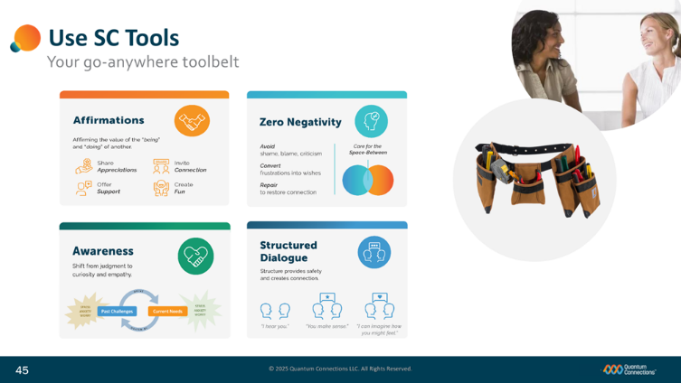
Slide 45
Here’s a quick introduction!
(advance bullet (Affirmations))
Affirmations are behaviors that support and highlight the uniqueness of each person, the power that differences offer us, and the value of connections between people.
When Affirmations are offered to other people, toxic negativity is diffused, and connections can be created and restored.
(advance bullet (Zero Negativity))
Zero Negativity is a commitment to avoid the use of shame, blame, or criticism towards others in your daily routines.
Creating a Zero Negativity environment better protects each person's self-image, promotes psychological safety and prepares the space between people for connections and relationship.
(advance bullet (Awareness))
Awareness is actively remaining receptive to a range of emotional truths: that we each deserve empathy, compassion, grace and space to remain different and unique.
Developing well-tuned awareness allows us to remain curious towards each other—even when we’re faced with some pretty challenging behaviors from other people.
(advance bullet (Structured Dialogue))
Our fourth and final tool is Structured Dialogue, a conversational template of six simple steps and sentence stems designed to encourage two-way, interactive speaking and listening. These language techniques have been proven out over four decades of clinical therapy, workshop practice, and the real-world experience of hundreds of thousands of people.

Slide 46
The first of these four tools is the practice of sharing affirmations with each other.

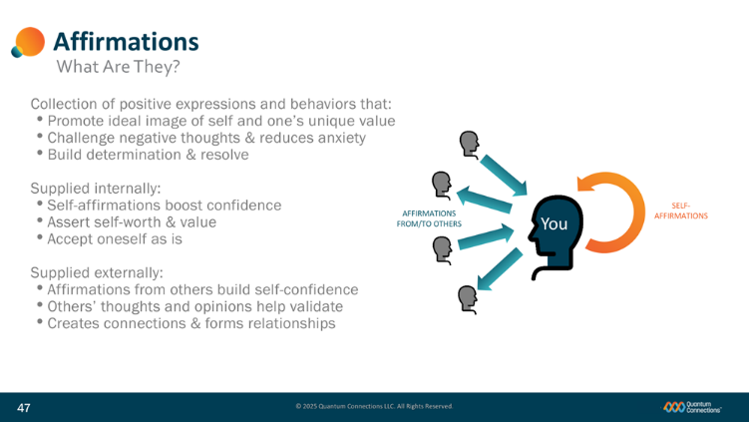
Slide 47
(advance bullets (Collection), (Promote…), (Challenge…), and (Build))
Perhaps you’ve heard of affirmations before? Affirmations are a collection of positive expression that promote self-confidence and reduce anxiety.
(advance orange graphic and bullet (Supplied internally…)))
Affirmations can be supplied internally, by someone providing themselves with a supportive self-talk or an internal voice to boost a person’s self-confidence and self worth.
(advance blue graphic and bullet (Supplied externally…)))
Affirmations could also be supplied externally by other people wishing to validate the value and uniqueness of another person, also building self-confidence and esteem in the process.
While those internal affirmations are certainly useful, our focus in the Safe Conversations’ Dialogue Workshop will be on the external affirmations that we supply to each other.
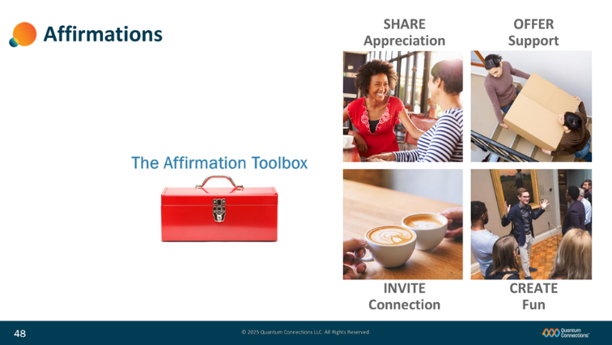
Slide 48
The practice of sharing Affirmations is a routine of using of four (4) Affirmations tools with the people in your life…
(advance bullet (The Affirmation…) and (SHARE…))
The first of these Affirmation Tools is to SHARE an Appreciation with someone. This is noticing and then sharing something about someone that you admire or respect. It could be a value, trait, or habit that you’ve observed and wish to recognize.
(advance bullet (OFFER…))
You can OFFER someone Support: This is when you do something for someone that they didn’t ask for and weren’t expecting. It is a spontaneous way to make them feel supported, like bringing them a cup of coffee, folding laundry, cutting the grass, or cleaning up the kitchen.
(advance bullet (INVITE…))
INVITATIONS to Connect are another great form of affirmation. These are requests or actions that indicate a desire to focus and spend a little time on your connection. For example, you could organize a surprise lunch or coffee/snack together, or a dinner out if it’s been some time since you’ve spent quality time together to visit.
(advance bullet (CREATE…))
Lastly, you can affirm the variety of different interests in others by CREATING fun experiences. For example, you could organize a day hike, mini-golf evening, birthday celebration or museum outing.
It is important to realize that different people respond differently to different types of Affirmation. Most people are motivated by forms of appreciation like these, but it’s possible that some may simply prefer more dedicated, personalized one-on-one conversation from you. Some people like to be celebrated and appreciated publicly in front of others, while other people may feel uncomfortable with the additional attention.
Everyone is unique, so take the time to continue to get to know the people in your life so you can understand what affirmations have the most impact for them.
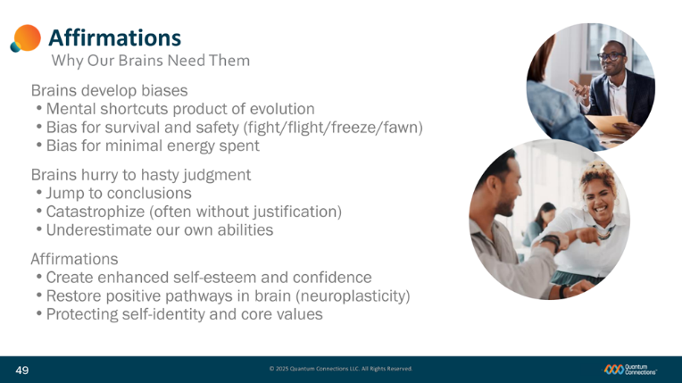
Slide 49
If you’re curious why affirmations are so important, there’s a good reason.
(advance bullets (Brains…))
Because of our instinctive nature to want to survive, our brains have evolved the habit of developing biases and shortcuts to facilitate quick-thinking and decision making. Doing so saves both time and energy- important quantities that might be in short supply in a pinch.
(advance bullets (Brains hurry…))
As brains develop these biases and shortcuts, brains hastily jump to conclusions and catastrophize, defaulting to the most negative interpretation—including underestimating and downgrading our own capabilities and self-image--as a function of self-preservation.
(advance bullets (Affirmations…)
Affirmations can create and repair self-confidence and self-esteem, re-write positive neural pathways in the brain, and boost and protect our impression of our abilities.

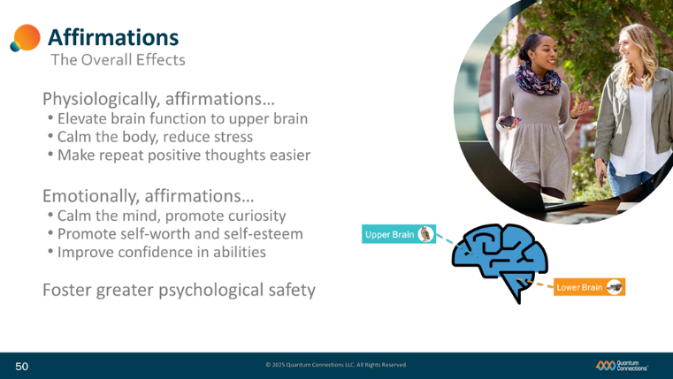
Slide50
For people dealing with high stress and anxiety, the lower brain signals neurotransmitters like adrenaline and cortisol to help spark some helpful physical responses like increased blood flow and bursts of short-term energy. However, if that high-stress pattern repeatedly leaves excess neurochemicals left about the body, the effects on health become detrimental, and promote chronic conditions like heart disease, high blood pressure and diabetes.
The introduction of affirmations affects us in two ways:
(advance bullets (Physiologically…) and next group)
Physiologically, affirmations drive brain processing up into the upper brain, and signal a different set of endorphins and neurochemicals (specifically dopamine, acetylcholine, norepinephrine, and serotonin), and help to counter the effects of stress and anxiety responses and instead promote happiness, calm and focus in the brain.
(advance bullet (Emotionally…) and next group))
Emotionally, those neurotransmitters not only calm the body, but also calm the mind. In the presence of affirmations, thinking is elevated into the upper brain where logic and balanced thought dominate. Brains can now more fully consider supportive ideas and override some of the precautionary underestimation caused by protective bias.
When people practice sharing affirmations in large numbers, the widespread creation of psychological safety encourages people to communicate more honestly and productively.

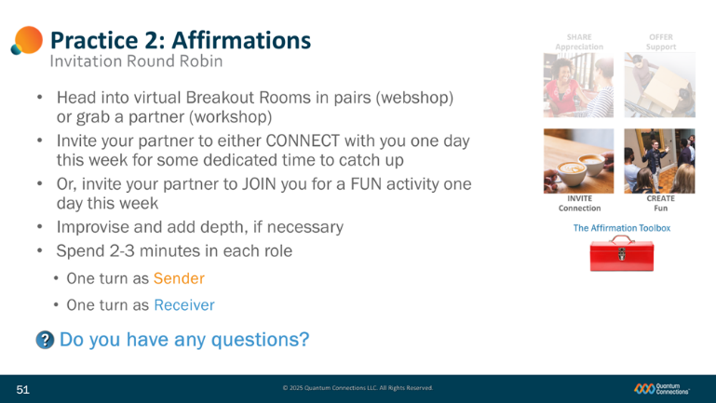
Slide 51
(advance bullets (Head into…), (Give…), and (Add…))
We’re now going to move into breakout rooms in our Webshop (or have you work with a partner in a workshop) to give you a chance to try out and practice some of your Affirmations’ Toolbox.
When it’s your turn to share, INVITE your practice partner to either some dedicated time to CONNECT one day this week, or INVITE them to JOIN you for a FUN activity, one day this week.
If you are just getting acquainted with your practice partner, improvise the details of the invitation, but go through the practice of actually extending the invitation. In your role play, add as much depth as you’d like.
(advance bullets (5-8…), (One…), and (One…) and depth graphic))
You’ll each get a chance to practice your invitation once, taking a turn with each role, once as the Sender and once as the Receiver. Take 2-3 minutes for each role and have a little fun with it. : )
(advance bullet)
Any questions for me? OK, let’s take (xx) minutes and then we’ll get back together and discuss.
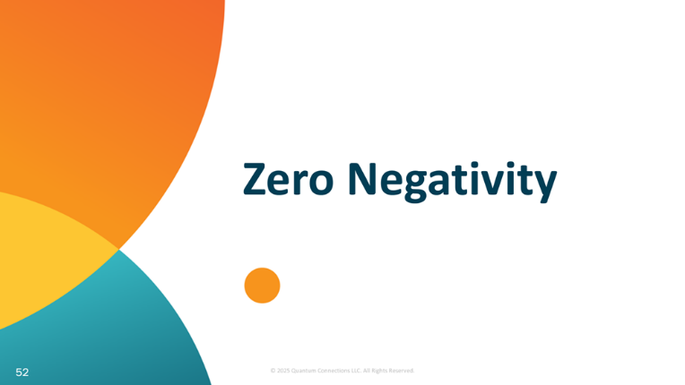
Slide 52
The second tool is called Zero Negativity.

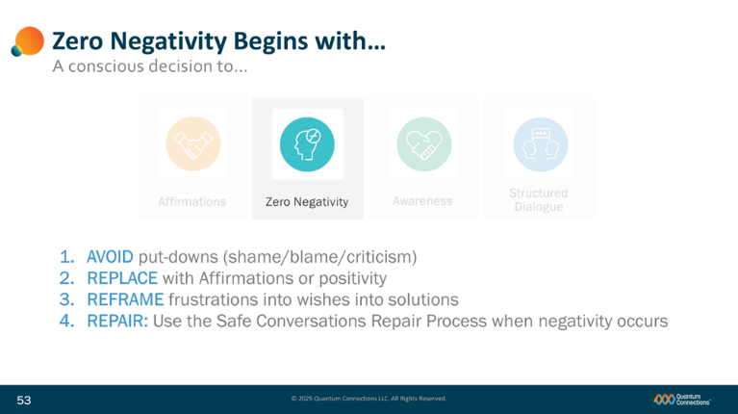
Slide 53
You start the use of this tool by making a commitment to Zero Negativity. What is negativity, you might ask? Simple enough, negativity is any form of shame, blame, criticism, ridicule, or outright hostility towards another person.
Making a Zero Negativity Commitment is a conscious decision to do four (4) things in the face of negativity:
(advance bullet (1.))
1. AVOID words, body language, or any other action that would be considered a put down by another person (especially shame, blame and criticism)
(advance bullet (2.))
2. REPLACE negativity with Affirmations or some other positively-framed contribution.
(advance bullet (3.))
3. REFRAME your frustration, challenge, or concern and express it instead as a wish or a request, often with some kind of solution in mind.
(advance bullet (4.))
4. REPAIR the situation promptly with your choice of remedies that will quickly restore your conversation and your connection.
The commitment is not about seeking perfection to live without ANY negativity or to live your lives by being falsely or blindly positive. It is about making a conscious effort to minimize negativity and when it does occur, dealing with it in a manner that promotes connection in your relationships with others.
In reality, negativity is going to happen, because we’re all human; what matters most is how quickly you can repair the connection and recover the positive energy in the Space-Between.

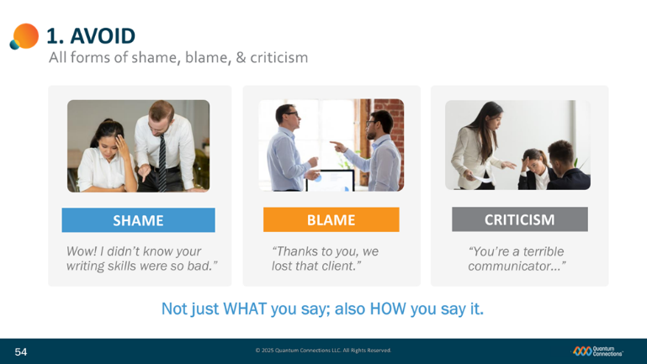
Slide 54
So if STEP 1 is to AVOID, it will be helpful to raise awareness and review the kinds of language and behaviors to avoid.
We start with the phrase ‘All forms of shame, blame, and criticism.’ This can be pretty tough when you think about just how much of this is out there.
(advance bullet (Shame…))
Shame is any form of insult that minimizes, demeans, or belittles another person. These hurtful comments can be private or public, direct or nuanced, or accidental or intentional.
(advance bullet (Blame…))
Blame is often alleged on others when accountability is not properly taken. Misplaced blame discourages initiative and rarely helps constructively address corrective next steps towards a solution.
(advance bullet (Criticism…))
Criticism focuses on faults and mistakes and discourages grace and forgiveness.
(advance bullet (Beyond…))
All in all, negativity is more than just words alone. Our actions, behaviors, and body language can also be experienced as Negativity.
It’s more than just purely what you say, it’s often ALSO how you say it.
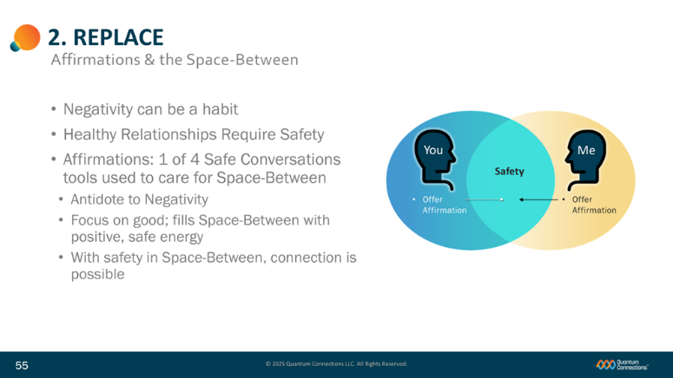
Slide 55
(first bullet appears with slide)
Sometimes, people are used to exhibiting negativity because it’s a habit or a kind of maintenance activity to keep themselves occupied or engaged. Simply telling people to avoid negativity is sometimes not as effective as suggesting something else to replace it with.
(advance picture and bullet (Healthy…))
As we discussed, the health of the Space-Between determines the health of relationships between people. To have healthy relationships, we need to keep the Space-Between safe.
For a number of reasons, Affirmations are a powerful tool to care for the Space-Between:
(advance bullet ((Affirmations…) and first bullet in list)
Affirmations are the antidote to Negativity and a great way to shift the energy in an interaction from hostile and negative and stressful to safe. It’s tough to be negative when you are giving or receiving an Affirmation.
(advance bullet (Focus…) and (With…))
Highlighting constructive, affirming things, we fill the Space-Between with positive energy. The energy we put into the Space-Between is felt by everyone in range; everyone in contact is lifted up by it.
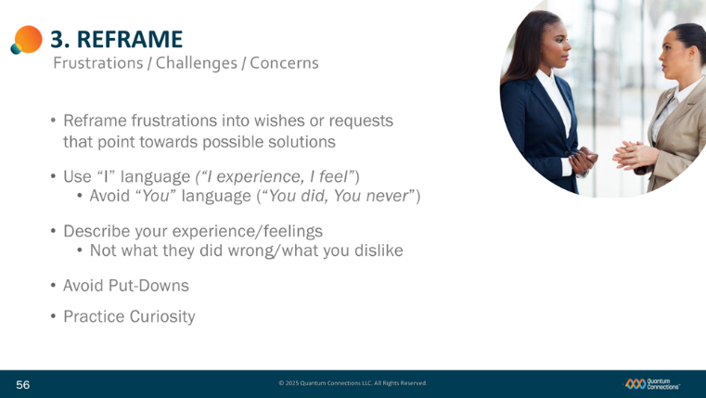
Slide 56
The third step in Zero Negativity is to think about frustrations, problems and other difficult topics in a different way.
(advance bullet (Reframe…))
Begin by reframing your frustration into a wish or request for a better outcome that is pointed in the direction of a possible solution.
Instead of focusing only on the problem (the proverbial “squeaky wheel”) help get the solution started by identifying at least one way that could help improve the situation for everyone.
(advance bullet (Use…) and (Avoid…))
Use “I” language instead of “you” language.
Ex: ”I experience…, or “I feel…” instead of “You did…, “You never…,” or “You always…”
(advance bullet (Describe…) and (Not…))
Describe your experience/feelings in neutral ways instead of what other people did wrong/what you dislike about them.
(advance bullet (Avoid…))
Avoid putting the other person down with shame, blame or criticism
(advance bullet (Practice…))
Practice Curiosity: When someone shares a frustration or concern with you, suspend your judgment, assumptions, and opinions. Try and step out of your world and explore things from their perspective: be curious about what’s going in in their head, why they think and feel the way they do and use the curiosity sentence stem: “Is there more about that?”
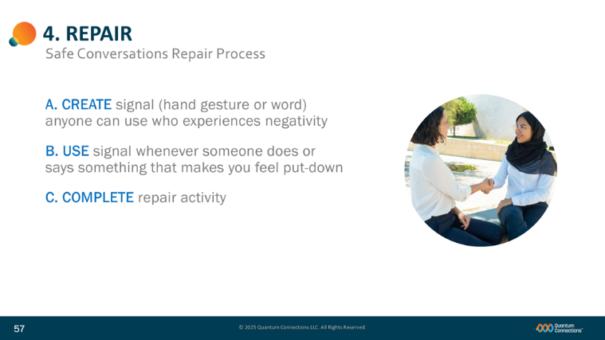
Slide 57
And finally, we round out Zero Negativity by keeping a Repair Process handy, a process that’s as easy as ‘A-B-C.’
(advance bullet (A. Create))
First, collectively agree on a negativity signal to identify negativity. Signals can be a unique word, a hand signal, or a combination of both.
(advance bullet (B. Use))
Commit to actually using the signal. Whenever someone feels put-down, they’ll signal the negativity to the sender.
(advance bullet (C. Complete))
Then, select a repair activity to use on the spot, from a list of options that we’ll discuss next.
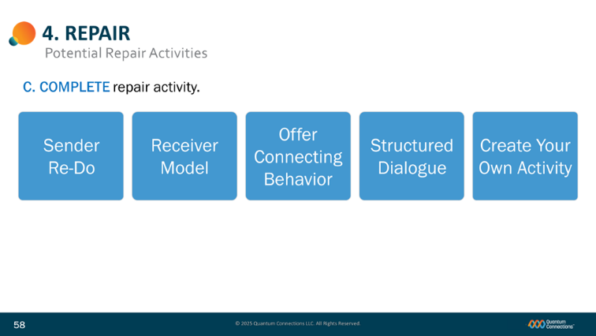
Slide 58
Those repair options include a Sender Re-Do, Receiver Modeling, Connecting Behaviors, Structured Dialogues and Custom activities.
(advance graphic (Sender…))
1) The first option is to volunteer or ask for a Sender Re-Do of the transaction or exchange. Following negativity and a signal, either:
1) the sender recognizes the negativity signal and volunteers to Sender Re-Do themselves, or
2) the receiver asks the other person, the sender, for a Sender Re-Do.
(advance graphic (Receiver…))
2) Following a negativity signal, the receiver—if the sender doesn’t recognize exactly what they said or did as negative—can simply model the transaction in a way that is more positive.
This option helps when the sender may not be aware of how they just displayed negativity and often helps the sender become more aware of how their actions impact others.
(advance graphic (Offer…))
3) Some examples of offering a connecting behavior would be actions or gestures like:
  - Take ownership and offer an apology,
  - share an affirmation,
  - ‘high five,’ or fist bump,
  - shake hands or shoulder tap, or
  - some other genuine attempt to re-connect will serve the purpose of offering to repair the positive energy.
(advance graphic (Structured…))
4) Because some issues are more serious and deserve a dedicated discussions, we recommend you offer a full Structured Dialogue. In this case, the Sharing a Frustration Dialogue is one of a series of specific Safe Conversations that we’ll supply you with to handle times when going deeper into the issue makes the most sense. For now, you can use the Mirroring sentence stems as a way to signal active listening and genuine curiosity to your conversation partner.
(advance graphic (Create…))
5) And last but not least, you are also free to create your own repair activity that’s well suited for the people in your world. As long as the activity 1) restores connection and 2) promotes safety for everyone, it’s a good approach.

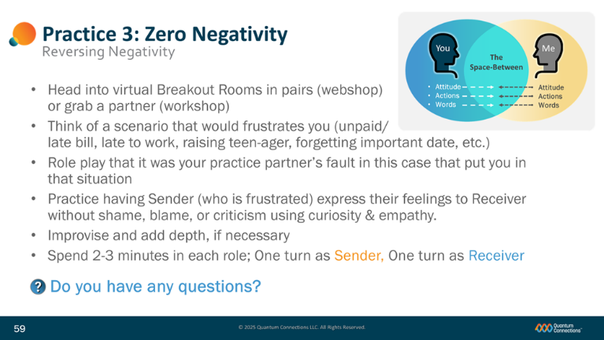
Slide 59
(advance bullets (Head into…), (Give…), and (Add…))
We’re now going to move into breakout rooms in our Webshop (or have you work with a partner in a workshop) to give you a chance to try out and practice some of your Zero Negativity mindset.
When it’s your turn to share, practice EXPRESSING your feelings without using Shame, Blame, or Criticism. In this role play, let’s suggest that you have an actual, valid reason to be frustrated. Practice expressing yourself without attacking the person, who in this case, appears to be responsible.
If you are just getting acquainted with your practice partner, improvise the details of the invitation, but go through the practice of actually expressing your feelings in a non-negative way. In your role play, add as much depth as you’d like.
(advance bullets (5-8…), (One…), and (One…) and depth graphic))
You’ll each get a chance to practice your expression once, taking a turn with each role, once as the Sender and once as the Receiver. Take 2-3 minutes for each role and have a little fun with it. : )
(advance bullet(Do you…))
Any questions for me? OK, let’s take (xx) minutes and then we’ll get back together and discuss.
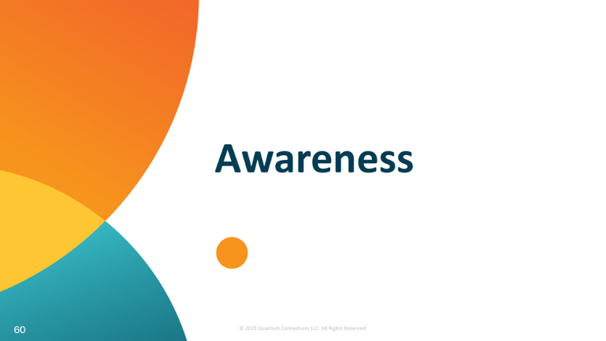
Slide 60
Having a model in our heads to remind us to remain aware is one of the best ways to promote psychological safety.

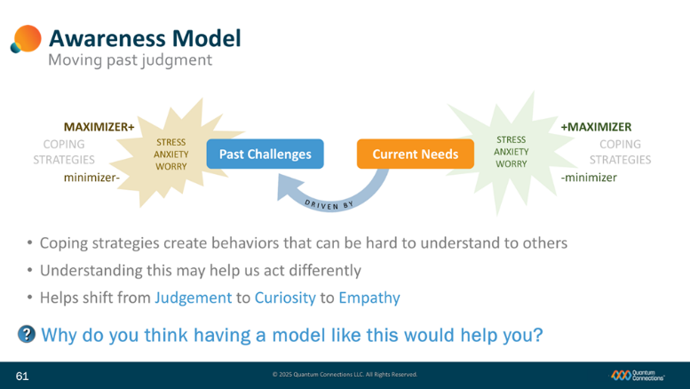
Slide 61
(Past Challenge and Current Needs boxes on slide to begin)
Here’s a model of how certain needs we have as human beings are impacted by events that have happened in our past. Understanding how we all respond to situations like these can help us all judge other people a little less critically, and empathize with them a little more.
(advance Driven By arrow)
Here you see that a person’s needs are in some ways driven by challenging events in our past. Whether you start with needs that a person currently has, and work back to the event that drives them—
(advance drive arrow graphic)
or you identify the past challenge, and trace forward to the needs that it creates for a person today—both are closely linked.
(advance both stress graphics)
Both ends of the model—whether that’s needs that go unmet today on the right side, or challenging events from our past on the left side--generate emotional reactions that produce stress, anxiety, and worry.
(advance coping strategies, (+)maximizer, (-)minimizer graphics)
Humans have evolved two principal coping mechanisms to deal with those reactions—to either MAXIMIZE the energy they feel, or to minimize the energy the feel.
(advance bullet (Coping…))
Often times those (+)MAXIMIZER and (-)minimizer coping mechanisms drive behaviors in other people that can be hard for us to understand. We witness these behaviors and wonder ‘why are they acting that way,’ ‘that makes no sense to me.’
(advance bullet (Understanding…) and (Helps…))
By spending some time with this model, it can serve as a tool to help us pause before racing to judgment, and move instead to a place with more curiosity and empathy—and more psychological safety, too.
(advance bullet (Why do...))
Let me ask you the question before we move on…
Why do think having a model like this would help you?
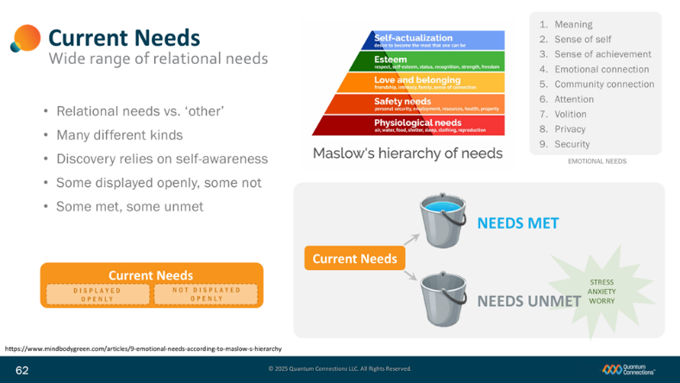
Slide 62
We’ll go deeper into the model’s two principal pieces: Current Needs and Past Challenges—and we’ll begin here with Current Needs.
(advance bullet (Relational…) and hierarchy graphic)
While everyone has a wide range of needs, what we’re talking about here is a person’s relational needs. You’ve probably heard of Maslow’s hierarchy of needs; in this case our emotional needs in the top half come soon after our basic physiological needs are met.
(advance bullet (Many…) and list of emotional needs)
The list of emotional needs includes many of the things we all generally experience—things like security, attention, and achievement.
(advance bullet (Discovery…)
Spending time thinking about your own needs helps you become more self-aware and also helps you become more considerate with respect to other people’s needs.
(advance bullet (Some displayed…) and Current Needs graphic)
Due to the personal nature of needs, some of these relational needs are shared openly and publicly, and some of them are not.
(advance bullet (Some met…) and Needs Met graphic)
Some of our relational needs are satisfied, and some others are not. Those that are not met and satisfied create stress, anxiety, and worry.

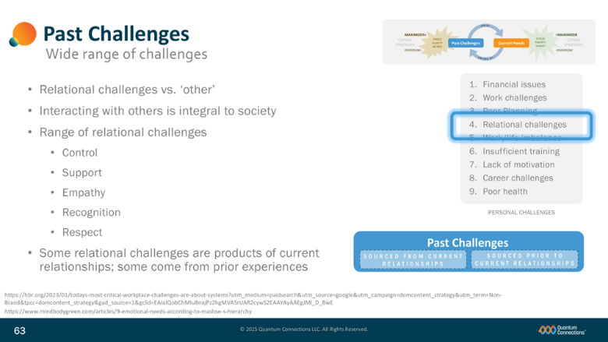
Slide 63
Similar to our range of relational needs, we all have our own unique collection of past experiences.
(advance bullet (Relational challenges…) and list of workplace challenges)
And while a number of things could probably qualify as ‘personal challenges,’
(highlight (4. Relational challenges))
what we’re talking about here are relational challenges that come about from interacting with other people.
(advance bullet (Interacting with…))
Because living with other people is integral to life today, this kind of relational friction is worth digging into a little deeper.
(advance bullet (Range…) and list)
Some of those challenges involve things like control, support, empathy, recognition and respect. Perhaps you’ve had to deal with issues involving these things at home or work—with a spouse, partner, boss, supervisor, friend, or co-worker even? If so, you’re like most people and you are pretty normal.
(advance bullet (Some relational…) and Past Challenge graphic)
When you think about your bigger challenges, some of them may be related to your very recent past and are connected to your current place in life. And it’s also true that some of your bigger relational challenges might not have anything to do with your current circumstances, but you still carry the past and their effects around with you all the same.

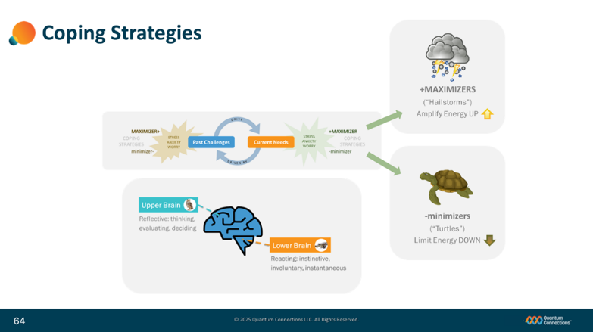
Slide 64
Now that you are a little more familiar with the kinds of current needs and past challenges that you and your family and friends are all working to manage, you’re now ready to talk about what happens when—despite our best efforts--those past challenges surface or those relational needs go unmet. We react.
(advance lower brain graphic)
Specifically, in those situations, the lower, reactive brain (that we discussed earlier) automatically jumps in and responds to all of the stress, anxiety, and worry created by the unmet need. The lower brain detects the lack of psychological safety and works to protect us by either (+)MAXIMIZING our energies to better respond to the stress, or by (-)minimizing our energies to better respond to the stress.
(advance (+)MAXIMIZER graphic)
Those people who generally respond to the stress, anxiety, and worry with amplified energies are called (+)MAXIMIZERS-- or “Hailstorms” to use a little more colorful label.
(advance (-)minimizer graphic)
Those people who generally respond to the stress, anxiety, and worry with reduced energies are called (-)minimizers, or Turtles for a more visual description.
Neither category is good, nor bad, only representative of a person’s general pattern of behavioral response to the stresses of unmet relational needs. These two categories are also not necessarily reflective of a person’s outward personality, but more so a description of the kinds of activities and behaviors they exhibits in response to stress.

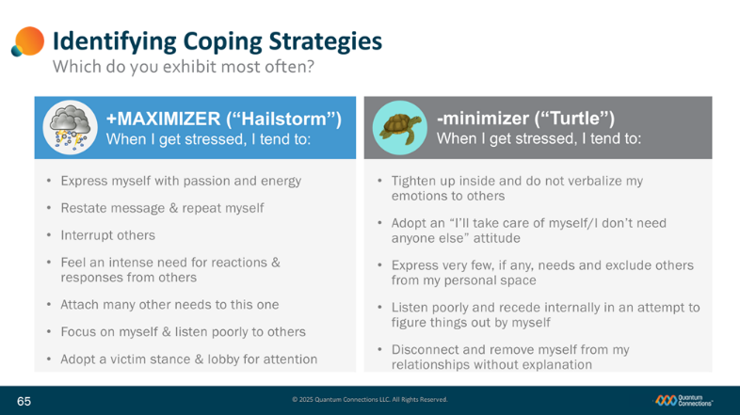
Slide 65
If you’ve ever wondered why people react the way that they do in certain situations, consider that it’s possible that their lower brains are driving their reactions and responses subconsciously. If they are dealing with some kind of past challenge or unmet relational need, their brains may be (+)MAXIMIZING or (-)minimizing their energies automatically to deal with the stress.
And what’s true for other people is also entirely true for you, too.
Take a minute to review the two coping mechanisms and identify which one of the two you recognize in your own responses and reactions to stress.
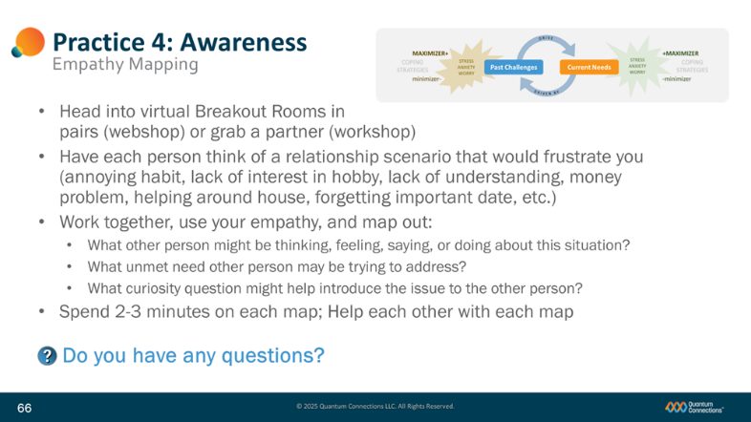
Slide 66
(advance bullets (Head into…), (Give…), and (Add…))
We’re now going to move into breakout rooms in our Webshop (or have you work with a partner in a workshop) to give you a chance to try out and practice some of your Awareness Model skills.
Take a personal situation—or make up a personal situation—that would be frustrating for you to experience with someone you’re close to: annoying habit, lack of interest in hobby, lack of understanding, spending/saving problem, helping around house, forgetting important date, etc. No question, you are an expert in your current perspective. Share that frustrating situation with your practice partner.
(advance bullets (Work…), (What…) x3, and (Spend…))
Working together, use your powers of empathy, and map out:
- What other person might be thinking, feeling, saying, or doing about this situation from their perspective,
- What unmet need the other person may be trying to address, and
- What curiosity question might help introduce the issue to the other person to begin to start talking about the issue in a productive way?
If you are just getting acquainted with your practice partner, improvise the details of the scenario, but go through the practice of actually mapping answers to the three questions asked. Get comfortable asking your partner how they might see the situation, and how they might see things differently than you do. In your role play, add as much depth as you’d like.
You’ll each get a chance to practice mapping your scenarios. Take 2-3 minutes for each role and have a little fun with it. : )
(advance bullet)
Any questions for me? OK, let’s take (xx) minutes and then we’ll get back together and discuss.
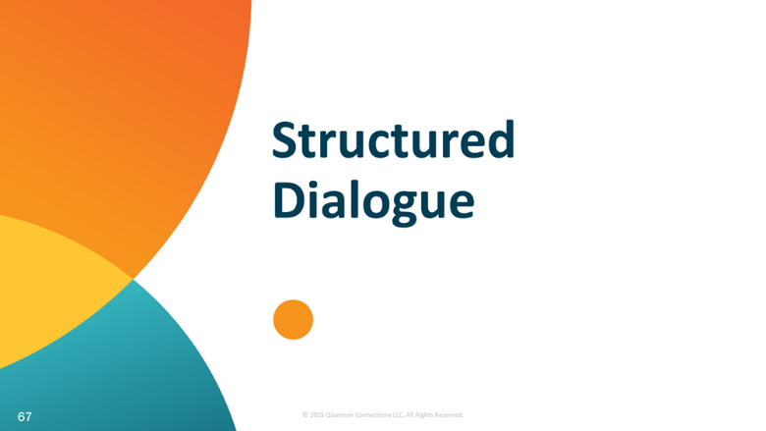
Slide 67
The last of the four (4) Safe Conversations’ Tools is Structured Dialogue.

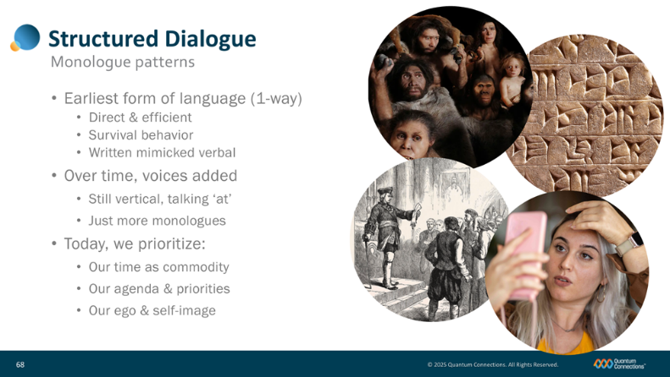
Slide 68
One fundamental challenge that makes good communications so difficult is the long-established pattern of the way we speak to each other. This communication pattern has dominated our behavior for the last several thousand years, and we call it monologue.
(advance bullet (“Earliest form…”) and graphic)
Monologue is our earliest form of communication where one person talks at another in a 1-way stream of information and emotion.
(advance bullet (“Direct…”) and list)
From our earliest days, when we learned to communicate with each other, we did so in a way that was short, sweet, and to the point—wasting little time and effort in the process.
Because we were always on the lookout for food, shelter, and danger, we were always working to conserve effort and energy—so we spoke directly and efficiently because our survival depended on it.
(advance bullet (“Written…”) and graphic)
When written forms of communication followed, they mimicked the verbal patterns that were already in place: just the message and little else. Adding more details would only take more time to chisel, glyph, or scribe, and so our communication styles did not evolve quickly to add feelings, depth, or reactions to the messages that were communicated.
(advance bullet (“Over time…”), list, and graphic)
Over time, human behavior and technology evolved and we began to express ourselves more often, but not—as it turns out-- much more interactively. As new social hierarchies and power dynamics emerged, we still reinforced the same vertical, directive communication styles where one-way proclamations and decrees characterized the way we spoke to each other. More and more enlightened people were talking AT one another, but it only seemed to be more monologues competing with each other for airtime.
(advance bullet (“Today…”), list, and graphic)
Today, they’re even more wrinkles to overcoming monologue:
Time has never felt in shorter supply, putting us all in a state of hurry,
Our own agendas dominate our days and dictate most of our time and our thoughts, and
Our focus on our own egos and self-images has never been more noticeable.
When you think about all of those things, it’s really no surprise that people don’t seem to take much time to listen, interact and connect with other people today. And while monologue is difficult to overcome, there is a proven skills that helps two people move past the challenge each and every time. It’s called dialogue.
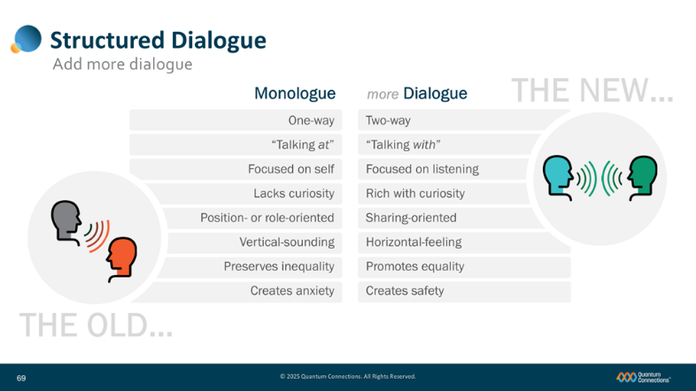
Slide 69
(Monologue bullets appear with slide)
If monologue tends to look like what’s on the left, then…
(advance Dialogue bullets)
…dialogue—what we’d like to replace it with--tends to look like what’s on the right.

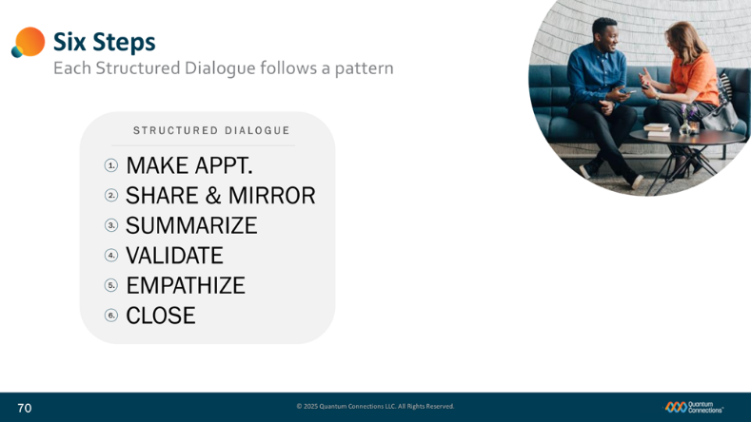
Slide 70
(no animation this slide)
The way that we build and create dialogue is with two people using the following six steps:
- Make an appointment.
- Share & Mirror.
- Summarize.
- Validate.
- Empathize.
and
6. Close the conversation.
Each Structured Dialogue generally features the same six (6) steps—in the same order.
We’ll now go into detail for each step.
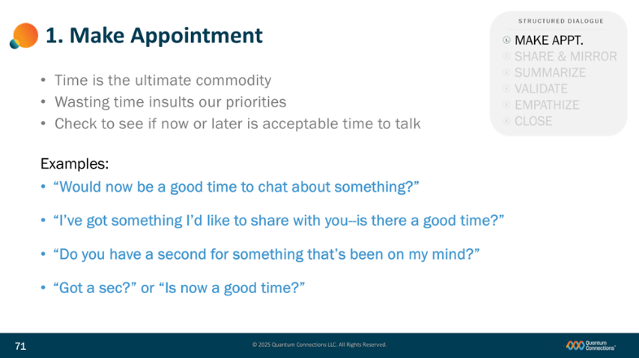
Slide 71
(first two bullets (Time…) and (Wasting…) advance with slide)
In today’s world, time has become the ultimate commodity. For many of the busiest people, wasting time insults their hectic schedules and workloads—and stops relational connection before it ever gets off the ground.
(advance bullet (Check to…))
The first step, Making an Appointment, simply involves the sender asking the receiver if now is a good time for a quick conversation—or finding another, more appropriate time a little later on.
(advance bullet (Examples:) and list))
Some examples of how this is done include:
“Would now be a good time to chat about something?”
“Do you have a second for something that’s been on my mind?”
or very simply:
“Got a sec?” or “Is now a good time?”

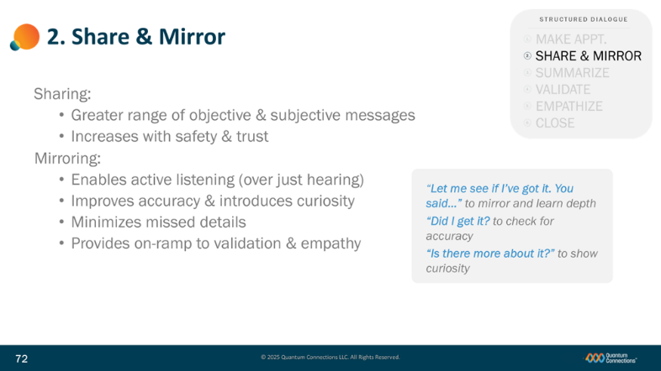
Slide 72
Earlier today, we introduced the Mirroring half of this step—which you all gave a try for practice.
(advance bullets (Sharing:), (Greater…), and (Increases…))
As a quick review, this 2-way step involves both Sharing and Mirroring.
The first half relies on a focused effort on the part of the sender to share both accurate information and genuine feelings—and benefits from the presence of safety and trust.
(advance bullets (Mirroring:), (Enables…), and (Improves…)
The second half leans on the receiver to use the three mirroring sentence stems—pictured here--to listen actively and demonstrate both curiosity and interest.
(advance bullet (Minimizes…)
Performing both of these two halves—the sharing and the mirroring--is very important in a world often focused on stuff we have to do, tasks, responsibilities, timelines and more. Mirroring will help minimize misunderstandings and help ensure that important feelings don’t fall through the cracks.
(advance bullet (Provides…))
Mirroring is also a critical step for follow-on steps Validation and Empathy. It is through effective Mirroring that you can best grasp what the other person is thinking, and feeling, and sharing with you. Normally, the better understand the depth of their thoughts, the better you can Validate and Empathize with them.
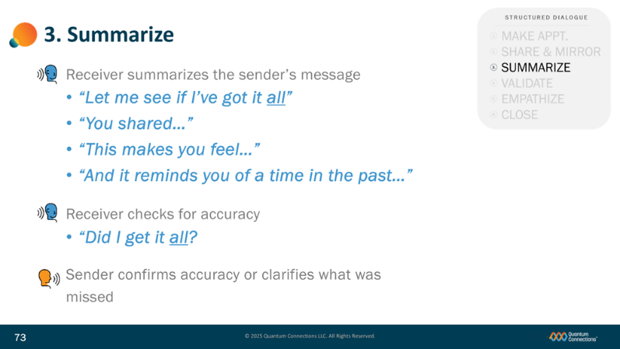
Slide 73
In the third step of the Structured Dialogue, the receiver summarizes the sender’s message.
(advance bullets (Receiver…) and (Let me see…))
Right up front, the receiver will add some signal that they are going to wrap up everything they’ve heard by adding some summary signal word like “all” or “everything” to the phrase “Let me see if I’ve got it all”
(advance bullet (You shared…))
The receiver will then continue with the phrase “You shared…” and then summarize the sender’s message as best they can.
(advance bullets (This makes…) and (And it…))
If the sender added depth and offered additional feelings, and past experiences and histories, then summarize those as well.
(advance bullets (Receiver) and (Did I…))
Once the receiver has summarized everything they’ve heard, they will ask the accuracy sentence stem “Did I get it all?” again, emphasizing the summary signal word “all” or “everything.”
(advance bullet (Sender…))
The sender then has the chance to listen to the summary and confirm that the receiver got everything or correct and/or clarify any missed details or misunderstandings.

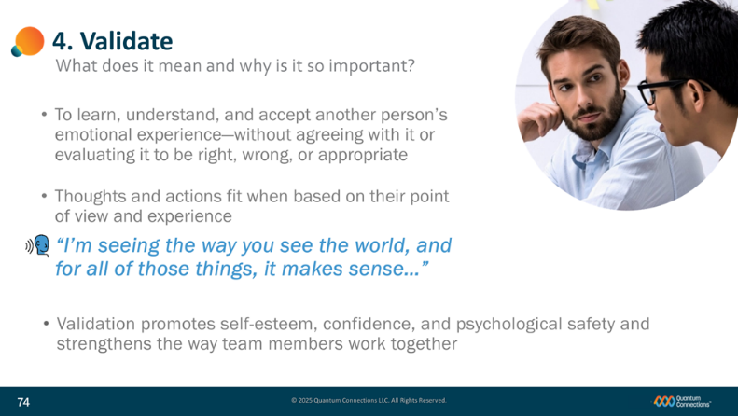
Slide 74
(first bullet appears with slide)
To validate another person, their message, and their emotional experience, a person only has to make an effort to learn about the other person’s feelings and understand that they make sense:
- for their situation and
- from their perspective.
(advance bullet (Thoughts…))
It’s about putting aside your own opinions, experiences and assumptions and choosing instead to look at the world through their eyes. What most people find is that other people have their own logic and reasoning—and that their thinking is based on an entirely different set of experiences than the ones that you have.
(advance bullet I’m seeing…))
To validate another person, you simply reach out to them to say: “I can see the way that you’re seeing the world, and in your situation, it makes sense.“
(advance bullet (Validation…))
Validation is a key step in building stronger relational connections—and goes a long way towards getting rid of some of the worst kinds of toxic defensiveness and replaces it with the psychological safety that the highest-performing teams depend on.
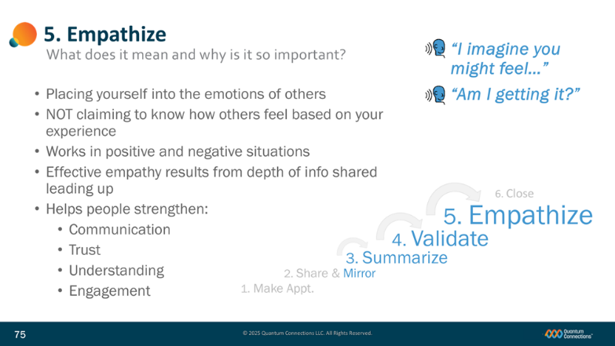
Slide 75
What does it mean to Empathize with another person, and why is it so important?
(advance bullet (Placing…))
Empathy is placing yourself into the emotional state of another person, as described by them and relative to their circumstances. Empathy is offered as a way to better relate emotionally with others and offer support, strength, and connection.
(advance bullet (NOT…))
Empathy is not claiming to know how another person feels because of a similar experience in your life. It is only an attempt to genuinely listen, see the world through another person’s eyes and imagine some of the feelings they are experiencing.
(advance bullet (Works…))
Empathy helps create stronger relationships amidst happy, joyful experiences as much as it does for painful and difficult events in life.
(advance bullet (Effective…) and dialogue progression)
The steps in the Structured Dialogue add value by building onto each successive step: the greater extent a Receiver can Mirror, Summarize, and Validate and their message, the greater depth and context they will have to empathize—and the greater ability they’ll have to build a meaningful connection with other people. Said another way, it’s hard to empathize in Step 5 if you have cultivated nothing to work with up until that point in the dialogue.
(advance bullet (Helps…)
Effective empathy between people helps:
- Improve communication
- Extend trust
- Deepen understanding of others’ behaviors
Increase engagement in your network
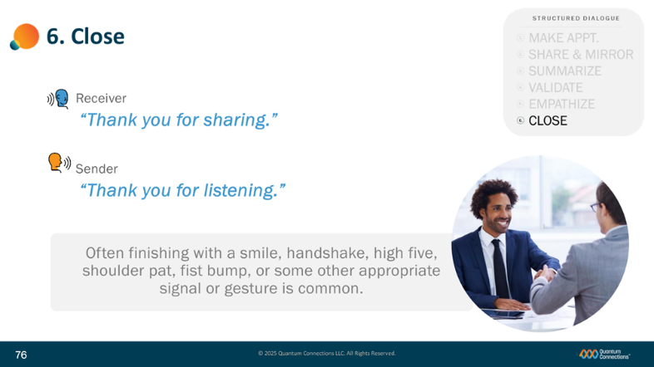
Slide 76
All that’s left in the final step is to make clear to all those participating that we are closing out the dialogue and showing our appreciation for each person.
Either person can take the lead and thank the other person and give the other person a chance to reciprocate.
(advance bullet (Receiver…) and (Sender…))
In this case, the Receiver says “Thank you for sharing.”
And the Sender says “Thank you for listening.”
(advance bullet (Often…) and handshake graphic)
Then, it’s common for both persons to engage in some kind of connecting behavior, whether that’s a smile, handshake, high five, shoulder pat, fist bump, or some other culturally-appropriate gesture or physical signal appreciative of the time and effort both people invested in becoming better connected.
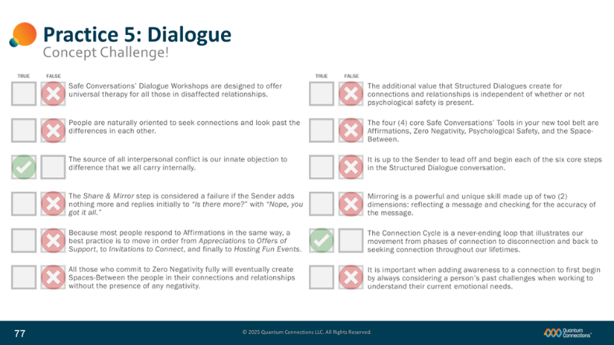
Slide 77
Our next exercise is a group concept challenge!
(advance First bullet (Safe Conversations’…)
I’ll call on participants for your response, either True or False.
Safe Conversations’ Dialogue Workshops are designed to offer universal therapy for all those in disaffected relationships.
People are naturally oriented to seek connections and look past the differences in each other.

The source of all interpersonal conflict is our innate objection to difference that we all carry internally.
The Share & Mirror step is considered a failure if the Sender adds nothing more and replies initially to “Is there more?” with “Nope, you got it all.”

Because most people respond to Affirmations in the same way, a best practice is to move in order from Appreciations to Offers of Support, to Invitations to Connect, and finally to Hosting Fun Events.
All those who commit to Zero Negativity fully will eventually create Spaces-Between the people in their connections and relationships without the presence of any negativity.

The four (4) core Safe Conversations’ Tools in your new tool belt are Affirmations, Zero Negativity, Psychological Safety, and the Space-Between.
The additional value that Structured Dialogues create for connections and relationships is independent of whether or not psychological safety is present.

It is up to the Sender to lead off and begin each of the six core steps in the Structured Dialogue conversation.
Mirroring is a powerful and unique skill made up of two (2) dimensions: reflecting a message and checking for the accuracy of the message.

The Connection Cycle is a never-ending loop that illustrates our movement from phases of connection to disconnection and back to seeking connection throughout our lifetimes.
It is important when adding awareness to a connection to first begin by always considering a person’s past challenges when working to understand their current emotional needs.


Slide 78
(no animation this slide)

The last topic in this section is a focus on various dialogue techniques to set you each up for success—and in a sense taking your new dialogue skills deep and wide.


Slide 79
We’ll tackle three specific aspects:
- the depth of the understandings you will create,
- the dialogue grid and the wide range of conversations it supports, and
- some various tips for communication success.

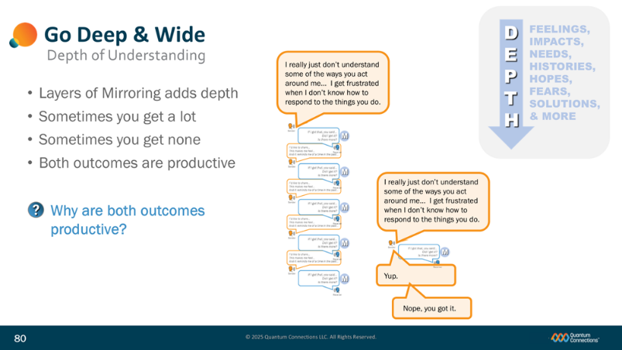
Slide 80
An important point that was introduced earlier in the Program--and is worth repeating--is this concept of generating depth of understanding with the Share & Mirror step of the Structured Dialogue.
(advance bullet (Layers of…) and depth graphic)
How well each receiver mirrors what is heard actually drives the quality and depth of what is shared by the sender. Taking the time to verify the accuracy of the message and then demonstrating genuine curiosity encourages the sender to share more. As the depth of sharing grows, and the psychological safety and trust grow right along with it, more and more layers of the message are uncovered. In the process, the receiver now has much more relatable substance to validate, and ultimately empathize over the course of each dialogue.
(advance bullet (Sometimes you…) and long graphic)
As you do more and more mirroring, you’ll see that sometimes the sender will respond to the receiver’s mirroring stems and add response after response, going on for some time, and yielding lots of layers of additional depth.
(advance bullet (Sometimes…) and short graphic)
And other times, the sender will quickly put an end to any additional sharing and follow-up by quickly saying something like “Nope, you got it all.”
(advance bullet (Both…)
In both cases, productive outcomes result.
(advance bullet (Why are…))
Some may or may not be so obvious, so I’ll ask you, Why do you think both outcomes are productive?
(survey responses.)
(If no one responds appropriately, longer mirroring exchanges deliver for the receiver much more additional information that can be validated and empathized—which greatly benefits the connection between the two. In very short/no mirroring exchanges, while there is not much additional information learned, the sender walks away believing that the receiver was willing and interested to listen more if the sender wished to share more, and in future dialogues, the sender might be more willing to trust the connection next time and share more helpful details and information.)
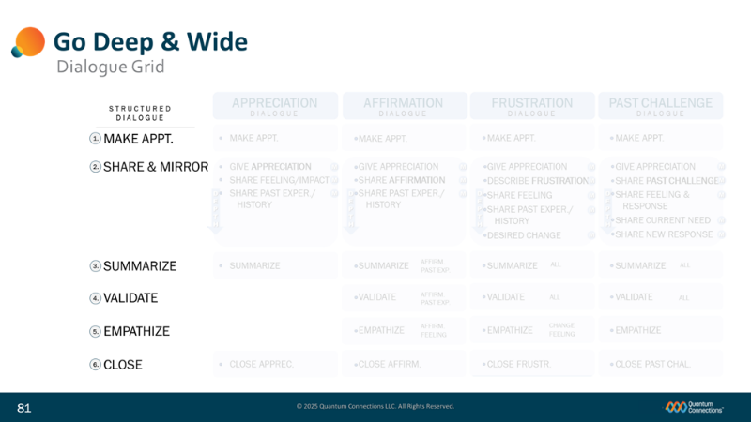
Slide 81
Here is a handy tool to help Structured Dialogue users integrate the 6-step tool into a variety of different situations. For the following four situations:
Sharing an Appreciation,
Sharing an Affirmation,
Sharing a Frustration, and
Sharing a Current Need and/or Past Challenge,
…all feature the same six-step dialogue template, but address slight variations along the way to help it fit perfectly into your desired purpose. A copy of this Dialogue Grid is available in your workshop Participant Guide.
(advance bullet Appreciation…)
Take the first dialogue, Appreciation Dialogue. Following the making of an appointment, Sharing/ Mirroring, Summary and Close round out the structured Dialogue. You’ll see that various items are listed in order to encourage the development of depth in the Share & Mirror section. Things like associated feelings, the impact related to the appreciation and any past history would all be helpful to be shared and mirrored between the two participants.
(advance bullet Affirmation…)
In the second example, the Affirmation Dialogue, someone wishes to share the value of an Affirmation that they have personally received with another person. They can also choose to relay how they best respond to affirmations—for the benefit of both the person and their partner. In doing so, they hope to share what kinds of things help them feel most seen and heard and valued. In sharing these Affirmations, they are also looking to reinforce this kind of behavior for more people they know.
(advance bullet (Frustration…)
The Frustration Dialogue might likely be one of the most useful tools we’ll share with you in the Safe Conversations’ Dialogue Workshop. As you can see, the same six steps are listed, but you’ll notice each step of the Share & Mirror progression is listed to help build meaningful depth for more productive Validate and Empathize sections later in the dialogue.
(advance bullet (Past Challenge…)
The last example, the Past Challenge (/Unmet Needs) Dialogue, sets the stage to share the impacts of a Past Challenge or a current unmet emotional need with someone that deserves to know more about you and understand you better. This conversation involves the greatest level of depth within the Share & Mirror section.
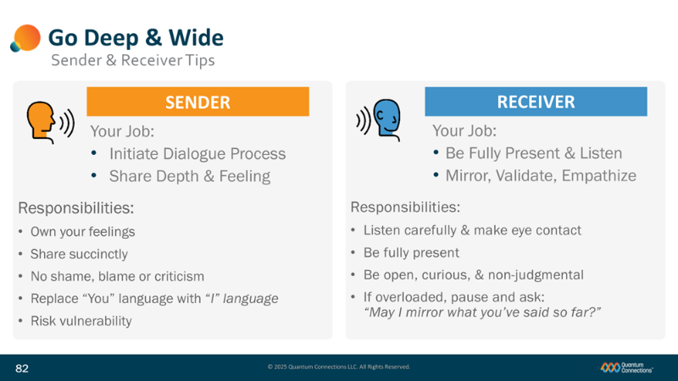
Slide 82
Within the Structured Dialogue, there are two principal roles—the sender and the receiver.
(advance bullet (Your Job…))
The sender’s job is to initiate the dialogue and share the message, the appreciation, the frustration with the other person.
(advance bullet (Your Job…))
The receiver’s job is to listen, mirror, and empathize with the sender and actually help create an active, two-way conversation between two people. Some of the six steps are Sender-initiated and some are Receiver-initiated.
(advance bullet (Responsibilities) and list))
Some of the sender’s responsibilities include demonstrating real ownership of the message by using “I” statements and language and avoiding the use of “you” attacks.
Senders also have the responsibility to aim for Zero Negativity as well as being succinct with their words. Succinct is not meant to be in a hurry or to leave out important parts—only to be mindful of everyone’s time, and to say everything that you feel, but do it in a way that get’s to the point.
(advance bullet (Responsibilities) and list))
Receivers have the responsibility to listen carefully and make and keep eye contact, being fully present, curious and non-judgmental.
It is perfectly ‘ok’ as a receiver to work in parts as you go, and to mirror with pieces of the message to keep the workload more manageable. The focus is on processing as much of the message as completely you can, on a pace that works for you.

Slide 83
(no notes or animation this slide)

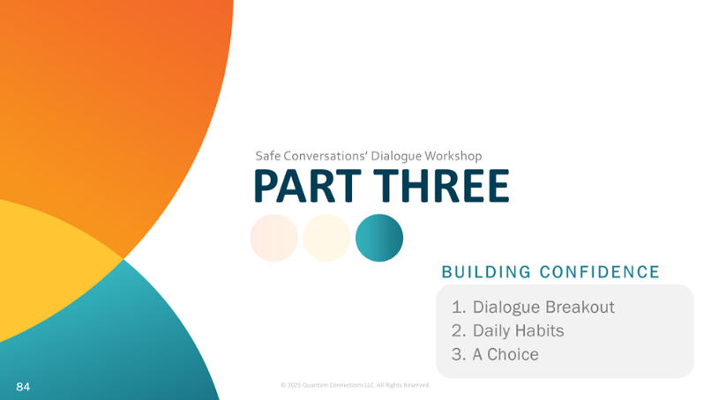
Slide 84
(no animation this slide)

The third and final section to our workshop will cover three things: practicing dialogue in breakout, establishing daily habits, and a choice to make regarding your developmental journey.


Slide 85
(no animation this slide)
We’re going to help you build even more confidence by going deeper into actual practice—in this case practicing all six steps of the structured dialogue.

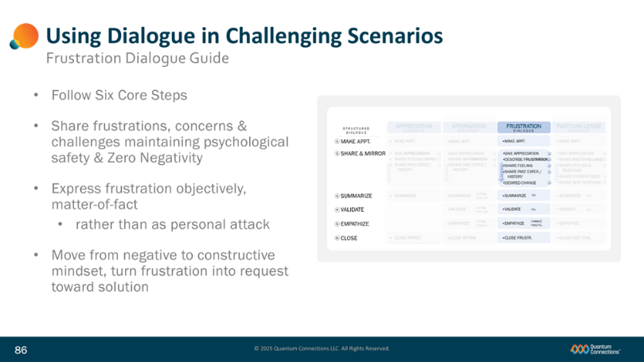
Slide 86
For the following demonstration and practice exercises, the Frustration Dialogue Guide can help you follow along each of the six (6) Structured Dialogue steps. We’ve posted a copy to the Chat Window here in Zoom, and you can find a copy within your Safe Conversations’ Dialogue Workshop Participant Guide.
The Frustration Dialogue helps:
(advance bullet (Share…))
• Relate frustrations in a healthy and safe way;
(advance bullet (Frustration…))
• Guides objectivity and helps avoid personal attacks;
(advance bullet (Move…))
• Converts negative frustrations into constructive requests for solutions.
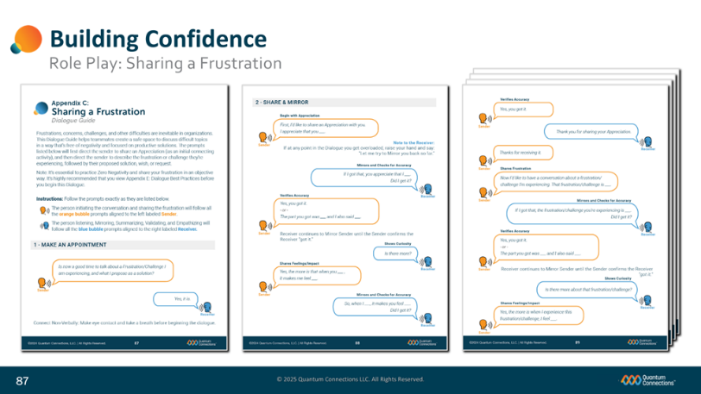
Slide 87
(no animation this slide)

Here is a look at the Sharing a Frustration Dialogue Guide, to help prepare you for what to expect. As you can see from the layout, each role is scripted to help you get acquainted with what to say…

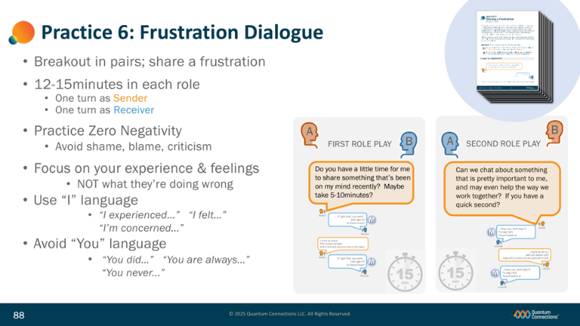
Slide 88
(graphic appears with slide)
For this practice, we’re going to place you in pairs into (digital) breakout rooms to conduct a practice run through the Sharing a Frustration Dialogue.
• We are going to give you 10-15 minutes for each role in breakout- one turn as the Sender and one turn as the Receiver. Feel free to share something that is genuinely on your mind that you’d like to discuss with your breakout partner, or feel free to ad lib or make up your own situation to role play.
(advance bullet (Breakout…)
(If you need the file, we’ve also re-posted this file for you in the Chat Window as an attachment.
Follow along in your Sharing a Frustration Dialogue Guide and stick to the process. These sentence stems work and have been validated by over 40 years of practical experience and clinical research.
(advance bullet (Remember…) and first two bullets on list)
One critical point I want to make: work hard to practice Zero Negativity while sharing your frustration. One of the most valuable elements of this dialogue for your team is the avoidance of negativity and the creation of safety in the Space-Between. Talk about your own experience and how you feel instead of what the other person did or did not do, or what is wrong with them.
(advance two bullets (Use…) and (Avoid…))
Use “I” language instead of “you” language.
“I experienced…I felt…I’m concerned…” instead of “You did…You are always…You never.”
If you focus on “You” language, you’ll trigger the other person’s defense mode and create Negative/Psychologically unsafe environments that will make problem solving difficult.

Slide 89
(no animation this slide)

(Discuss the practice experiences of program participants.)

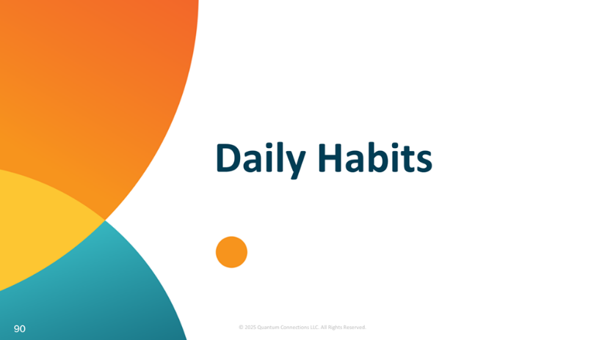
Slide 90
(no animation this slide)
Let’s discuss how we hang onto to all that we’ve discussed today—in the form of creating some brand new daily habits.

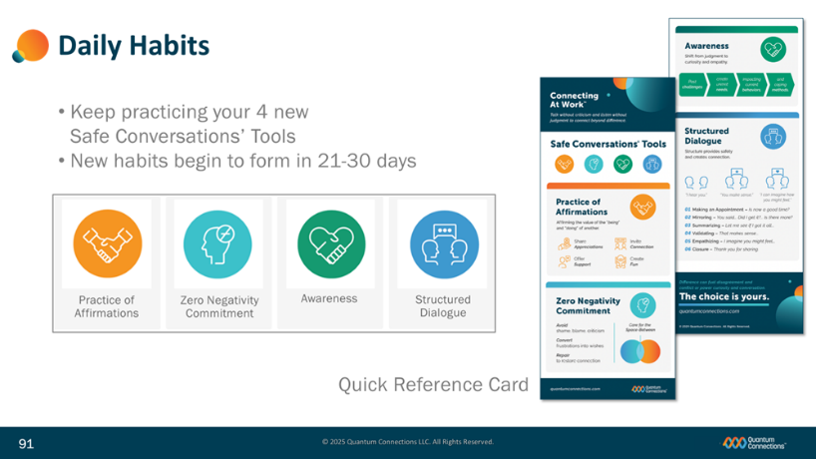
Slide 91
(no animation this slide)
In many ways it all seems so simple- just talking honestly and listening carefully, right? So why does it sometimes become so hard?
Well, remember, you’re adopting brand new skills and creating a whole set of new habits. You are re-conditioning generations of learned and instinctive behaviors.
Becoming more relationally competent will take some time and daily practice—and in some cases, these habits take weeks to take hold.
To help you practice, a digital copy of our Quick Reference Card is included in your Safe Conversations’ Dialogue Workshop Participant Guide to remind you of your new skills and tools.
Let’s quickly review your new skills and tools…

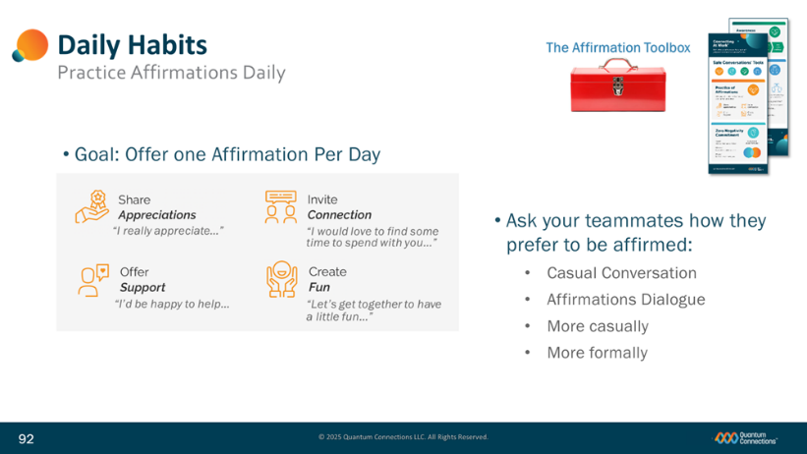
Slide 92
(no animation this slide)
Affirmations are expressions of appreciation, offers of support, invitations to connect, and opportunities to have fun that validate the contribution, expertise, growth and uniqueness of another person. Just like the baby in the Still Face video, we all crave appreciation and affirmation.
Consider how you can use a combination of these four tools to:
• add spirit and variety to the people in your world,
• promote connecting in your relationships, and
• build psychological safety among each of your family members and friends.
Take the time to ask others how they prefer to be Affirmed – either through casual conversation or by using the Affirmations Dialogue Guide.
Affirmations are not about what someone does for you; it’s about pouring value into the Space-Between and training our brains to focus on the positive.
You’ll want to leverage your Affirmations toolbox daily to create and maintain connection and also when you are feeling disconnected from the people around you. Just consider your toolbox and ask which Affirmation may be best applied at that moment.
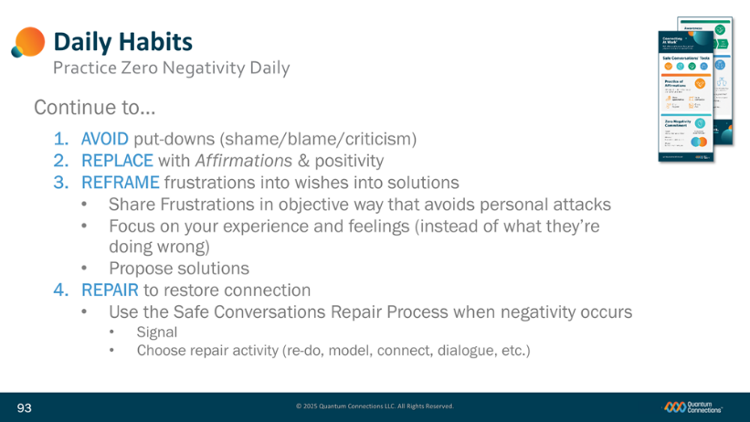
Slide 93
(no animation this slide)
You learned that a Zero Negativity Commitment is a conscious decision to do four (4) things in the face of negativity:
AVOID any words, body language, or any other action that would be considered a put down by another person (especially shame, blame and criticism)
REPLACE negativity with Affirmations and other positive elements.
REFRAME your frustration, challenge, or concern and express it instead as a wish, request, or solution.
REPAIR the situation promptly with an agreed upon signal and your choice of repair activities, such as Sender Re-do, Receiver Model, Connecting behavior, or Sharing a Frustration Dialogue, to quickly restore your conversation and your connection.
Zero Negativity is NOT about being falsely cheerful or positive all the time. It’s still helpful to the relationship to discuss challenges, concerns and frustrations.
Negativity is going to happen, because we’re all human; what matters most is how quickly you can recover the positive energy in the Space-Between.
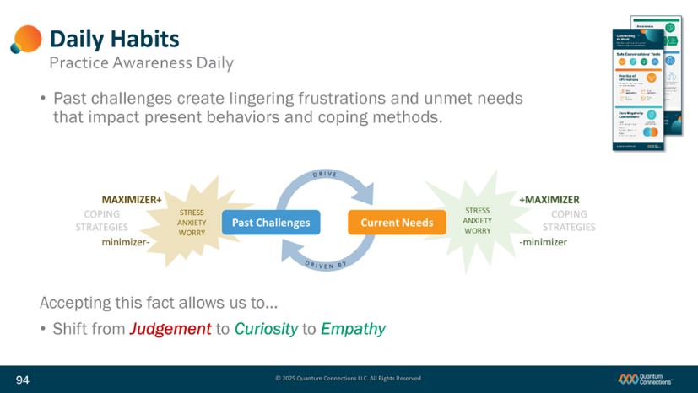
Slide 94
For every human on the planet, we all experience challenges throughout our lives. We face difficult and sometimes painful experiences with family members, trials in workplaces, and many other challenges in life related to personal histories or circumstances.
For most people, these past challenges create lingering frustrations and unmet needs that impact our current interactions.
These challenges could be from long ago, such as childhood, but they could also be as recent experiences that we are still processing.
As a result, we all develop coping methods that kick in when current needs are not met. We either (+)MAXIMIZE or (-)minimize our energy in response - becoming a “Hailstorm” or “Turtle” independent of our personalities.
Reminding ourselves of the Awareness Model helps us accept when someone is showing unexpected behaviors they may be responding to an unmet need being triggered by the present experience.
(advance bullets (Accepting…) and (Shift…))
Instead of judgement and assumptions, we respond to them with curiosity and empathy. This regulates the interaction, stopping negative behaviors and restoring the connections we all need.
This Conscious Awareness is a new skill that has the power to transform your relationships with others. Oprah Winfrey called the realization of the role that past challenges play one of the biggest “A-HA” moments of her career. When you feel you are operating in your reactive lower brain, you will need to call upon this skill to help you pause and consider what is happening in the moment.
Your ability to shift from judgment to curiosity and empathy, to employ your dialogue skills, to purposely avoid the negativity these situations can create can make all the difference in your ability to collaborate, create, and connect with other people.
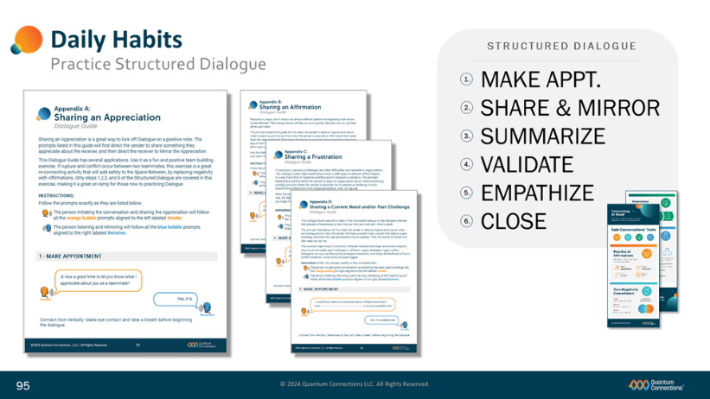
Slide 95
(no animation this slide)
When you find yourself or others in a particularly challenging situation – where you need to share frustrations, concerns, and challenges, where emotions are high, where the relationship is valuable and you need to preserve the connection – you can use the six-step Structured Dialogue in any of a variety of situations.

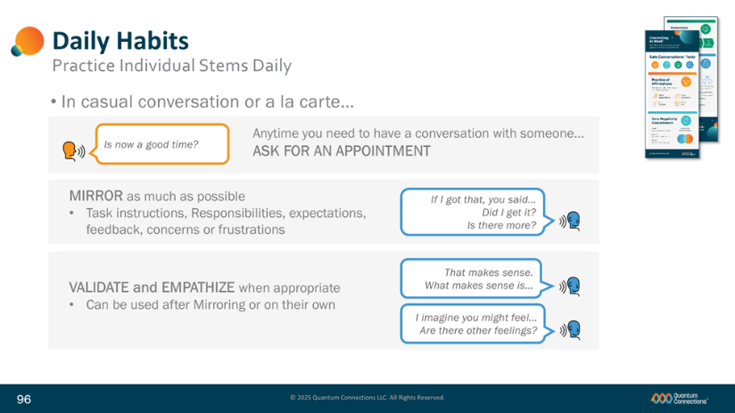
Slide 96
(no animation this slide)
Don’t forget that you can also apply the individual sentence stems that make up the Structured Dialogue in everyday casual conversations where they fit to help you to connect with others.


Slide 97
(no animation this slide)
That leaves us all with an important choice to make…

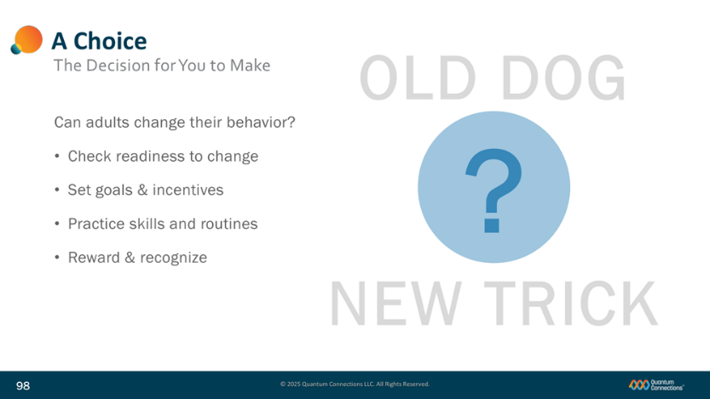
Slide 98
(first bullet (Can Adults…) appears with slide)
There’s no question that trying to change long-established behaviors for adults is hard work.
A couple of things can help a person who is trying to say and do things differently…
(advance bullet (Check…))
Things like:
Spending some time thinking about their own motivation to change and how serious they are about doing something about it.
(advance bullet (Set…))
Setting goals and milestones of progress, with reasonable levels of change, realistic timeframes, and some attractive incentives to keep you motivated.
(advance bullet (Practice…))
Identifying specific skills and habits to address and finding space for them within your existing routines.
(advance bullet (Reward…))
And finally, rewarding your own progress, even if it is just a part of the way towards your new goals of communicating more safely and connecting more deeply with people. Take time to recognize the work and results you’ve put in, and just as important, the work and results of others as well.
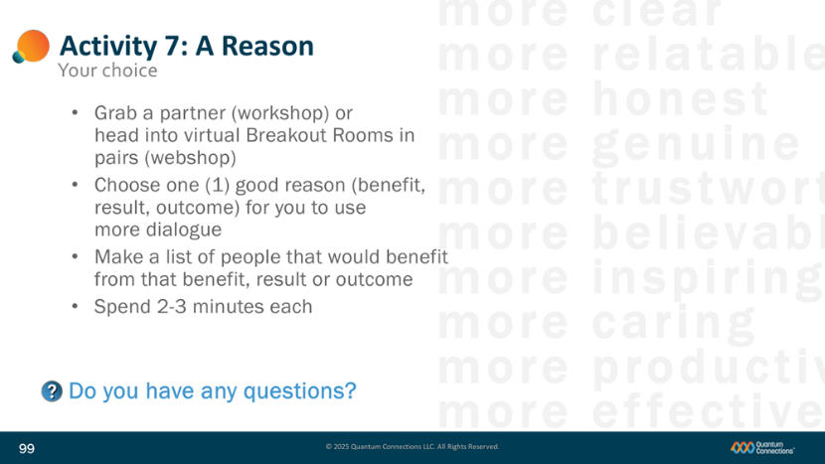
Slide 99
Our final activity is to work with a partner to discuss your reasons for adopting Safe Conversations into your lives. In a lot of cases, having a clear picture of what and why you're working to make these changes will help preserve the motivation to put in the work.
(advance bullets (Grab…) and (Choose…))
Grab a partner and take turns sharing one good reason, or benefit, or result, or outcome of your taking on Safe Conversations, of building more psychological safety, and of using your four new tools of Affirmations, Zero Negativity, Awareness, and Structured Dialogue.
(advance list of descriptions long the right side)
(advance bullet(Make…))
Once you picked out a reason that will serve as your principal motivation, next make a list of all of the people that stand to benefit by you taking on these new Safe Conversations skills and behaviors. This is where a lot of people realize that this workshop goes way beyond simply trying out a few new sentence stems and phrases.
(advance bullet (Spend…))
Let’s append about (x) minutes together and then we’ll get back together and invite you to share your reasons if you’d like to.
(advance bullet (Do you…))
Any questions for me? OK, let’s head to your practice and then we’ll get back together and discuss.

Slide 100
(No notes or animation this slide)

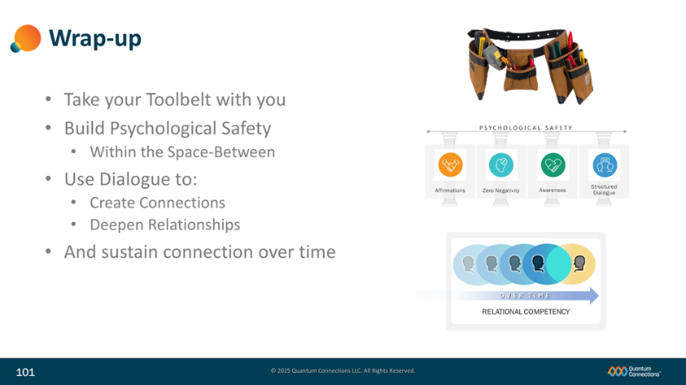
Slide 101
As a quick review…
(advance bullet (Take your…))
Don’t forget that you now have a powerful new toolbelt with four helpful tools—keep it always at the ready and use Affirmations, Zero Negativity, Awareness, and Structured Dialogue liberally throughout all of your interactions with others.
(advance bullet (Build…))
Keep in mind that the purpose of those tools is to create greater psychological safety within your sphere of connections and relationships. That safety will help people relax, open up, take risks and build deeper bonds amongst a variety of people with all kinds of wonderful differences.
(advance bullet (Use…)
Two-way, interactive dialogue is the vehicle that will power this new change in you and this new change in the world. Don’t underestimate the power that it can have over the connections and relationships that care more deeply about.
(advance bullets (And…))
And finally, better connectivity and relational competency is not a one-time event, to be achieved in a moment and then put on a shelf and retired. Remaining connected requires a commitment to remain tolerant and curious, to talk without criticism, to listen without judgment, and to connect beyond difference as a new way of life.
Thank you for your time today.
Slide 102

(No notes or animation this slide)

END OF PRESENTATION

